The Inter-Faith Chapel

“A House of Prayer for All People”

3680 South Leisure World Blvd.
Silver Spring, Maryland 20906

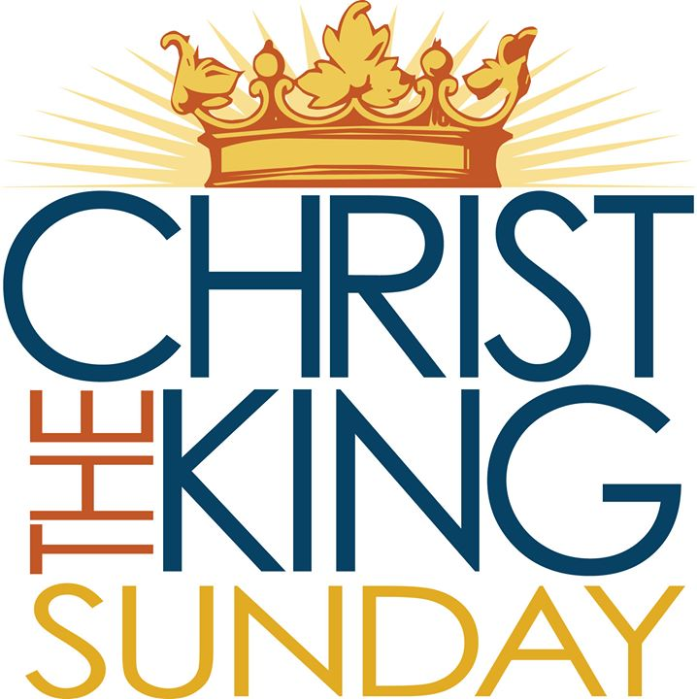

November 26, 2017

Christ the King Sunday
9:00 AM Worship Service 11:00 AM

 As you enter to worship, please remember to silence your cell phones. 

SILENT MEDITATION
Throughout the Gospel of Matthew, Jesus' teaching has announced and illustrated the kingdom of God. God's kingdom does not function like a typical kingdom. This divine reign has invaded the world and is good news -- especially to those on the fringes of society. This rule welcomes those who have no status and seeks to serve others rather than exploit them. Carla Works
WORDS OF WELCOME Dr. Ramonia L. Lee

LIGHTING THE PEACE CANDLE

We light this candle as a symbol of our ongoing commitment to peace in our world.

PRELUDE Christ the King (Agincourt) Frederick Swann
Kevin M. Clemens, Director of Music

CALL TO WORSHIP Rev. Barbara McKenzie

Leader: Around the world this day,
the universal church celebrates the “The Reign of Christ.”
Christ Jesus, friend of the poor, the meek and the merciful,
has been enthroned above all authority and power
in this world and in the world that is to come.
PEOPLE: Make a joyful noise to the Lord, all the earth,
serve the Lord with gladness
come into his presence with singing.
Leader: God has placed everything under Christ’s wounded feet,
appointed the One who wore a crown of thorns
as the supreme head of the church, His body.
PEOPLE: Enter His gates with thanksgiving,
come into His courts with praise.
Give thanks and praise His loving name!

 HYMN All Hail the Power of Jesus’ Name
INVOCATION
 Those who are able are invited to stand.
Music used by permission, CCLI #1683224

CALL TO CONFESSION

PRAYER OF CONFESSION UNISON
Loving God, too often, we overlook the needs of people around us while we proclaim our devotion to you. We could do so much more to feed the hungry, clothe the naked, to welcome the stranger, and heal the sick. We fail to see how our prison system diminishes the humanity of all of us, how our medical system denies healing to the poor, how poverty leaves children without coats, how legal obstacles keep the strangers at a distance. Open our eyes to see your presence in every person, and to respond to their needs so that we may be rightly called by your name. Amen.

WORDS OF ASSURANCE

 AN AFFIRMATION OF FAITH

As followers of Jesus Christ,
living in this world—
which some seek to control,
but which others view with despair—
we declare with joy and trust:

Our world belongs to God!
From the beginning,
through all the crises of our times,
until His kingdom fully comes,
God keeps covenant forever.

Our world belongs to Him!
God is King! Let the earth be glad!
Christ is Victor; His rule has begun. Hallelujah!
The Spirit is at work, renewing creation. Praise the Lord!

We rejoice in the goodness of God,
renounce the works of darkness,
and dedicate ourselves to holy living.
As covenant partners,
called to faithful obedience,
and set free for joyful praise,
we offer our hearts and lives
to do God's work in his world.
With tempered impatience, eager to see injustice ended,
we expect the Day of the Lord.
And we are confident
that the light which shines in the present darkness
will fill the earth when Christ appears.

 GLORIA PATRI
Glory be to the Father, and to the Son, and to the Holy Ghost;
As it was in the beginning, is now, and ever shall be,
World without end. Amen. Amen.

SCRIPTURE READING Ezekiel 34:11-16, 20-24 OT 984
Readers: 9:00 AM Juanita Sealy-Williams 11:00 AM Maggi Lindley

ANTHEM Jesus, the King Lloyd Larson
Chancel Choir

MORNING PRAYER

LORD’S PRAYER UNISON

Our Father who art in heaven, hallowed be thy name. Thy kingdom come, thy will be done, on earth as it is in heaven. Give us this day our daily bread. And forgive us our sins as we forgive those who sin against us. And lead us not into temptation, but deliver us from evil. For thine is the kingdom, and the power and the glory, forever. Amen.

SCRIPTURE READING Matthew 25:31-46 NT 35

HYMN Where Cross The Crowded Ways of Life

SERMON “When Christ the King Comes” Dr. Ramonia L. Lee

INVITATION TO OFFERING

OFFERTORY God, My King, Thy Might Confessing Albert Lowe
Chancel Choir

 DOXOLOGY (Tune: Lasst Uns Erfreuen)

Praise God from whom all blessings flow;
Praise God, all creatures here below;
Alleluia! Alleluia!
Praise God, the source of all our gifts!
Praise Jesus Christ, whose power uplifts!
Praise Spirit, Holy Spirit!
Alleluia! Alleluia! Alleluia!

 PRAYER OF DEDICATION

 PASSING OF THE PEACE

 CLOSING HYMN Jesus Shall Reign

 RESPONSIVE BENEDICTION
Leader: We will go now into God's world:
People: to bring healing to the sick and hope to the despairing.
Leader: We will go now to serve Jesus' sisters and brothers:
People: to offer a hand to those who have fallen,
to put a warm coat around those who shiver in the cold.
Leader: We will go now to share the Spirit with everyone we meet:
People: to be a companion to those in prisons as well as those bound by injustice, to bring the cup of grace to every parched soul.
Leader: Amen.
People: Amen.

 CONGREGATIONAL RESPONSE Tune: Ar Hyd Y Nos

“Go, my children, with my blessing, never alone.
Waking, sleeping, I am with you, you are my own.
In my love’s baptismal river I have made you mine forever.
Go, my children, with my blessing, you are my own.”

POSTLUDE Carillon-Sortie Henri Mulet
Kevin M. Clemens, Director of Music

A PARTING THOUGHT
"The difference between followers of Jesus and those who do not know Jesus is that those who have seen Jesus no longer have any excuse to avoid 'the least of these.” -Stanley Hauerwas
Welcome To The Inter-Faith Chapel

We are committed to being “A House of Prayer for All People.”

We are seeking to share God’s love and care through outreach, study, and worship. We invite you to share with us in this journey.
Believing that God’s love and welcome are extended to everyone,
we strive to make our worship experience accessible to all.
- Hearing Assistance Devices are available in the Narthex.
- Large Print Bibles are available in our Library.
- Space allowing extra room for wheelchairs and walkers, along with companion seating, is located immediately inside the Sanctuary.
If you need any accommodations while here, our ushers are happy to assist.

ALTAR FLOWERS Dedicated by Yvonne Williams in memory of her husband
Rev. John Williams on his November 27 birthday

USHERS 9:00 AM Louis Katsouros, Head Usher
Clydis Kellough, Pat McConnell, Naomi Rogers

USHERS 11:00 AM Louise Langley, Head Usher
Jill Glixon, Arlene Kaiser, Fredreika Smith

GREETER 9:00 AM Ruby Ricks

GREETER 11:00 AM Ruth Witt

FLOWER MAKERS Regina Lash and Kimi Sugimura

Delivery of Altar Flowers on Monday, November 27
Beryl Adams  Anna Pappas
Presence on Sunday, November 19
9:00 AM: 89  11:00 AM: 114  Total: 203
Offering  $5,518 | Weekly Budget  $7,788*
Year to Date Offering  $375,982 | Year to Date Budget  $359,586*

*This amount represents offerings received and pledge budget only and does not reflect approved withdrawal of $12,380 per month from the endowment fund needed to meet overall 2017 operating budget.

ANNOUNCEMENTS & OPPORTUNITIES

VISITOR REGISTER If you are a visitor at The Inter-Faith Chapel, we are so pleased you chose to worship with us today. Please sign the Visitor Register located in the Narthex that we might have a record of your attendance, and please receive a coffee cup as a small welcoming gift. We are delighted that you are here today and hope that you will return again soon!

NEW MEMBER REGISTER We would love for you to consider membership with this dynamic and active family of faith. If you are interested in joining The Inter-Faith Chapel, please sign the Member/Affiliate Register located in the Narthex near the coat closet and we look forward to being in contact with you.

CHRISTMAS DECORATING All are welcome to come and help decorate The Chapel, for our Advent and Christmas season. Christmas music will be playing and light refreshments will be available. Gather at 9:00 am on Saturday, December 2.

ANNUAL MEETING The Annual Congregational Meeting will be held on Sunday December 3, immediately following the 10:00 worship service. During the meeting, we will vote to approve the budget and to elect officers for 2018. Please make plans to attend this important meeting and pick up an informational packet in the Narthex that includes the proposed budget and slate of officers.

HELP OTHERS CELEBRATE CHRISTMAS! Home baked cookies that do not contain nuts are needed for our Christmas gift bags. Bring three dozen cookies, labelled for gift bags, to the kitchen on Sunday, December 3. Volunteer drivers are needed to deliver these bags to members and friends who live in Leisure World or nearby care facilities. Come by the fellowship hall on December 7-17 to pick up bags to deliver. Pick up gift tag(s) in the Narthex for socks and toys gifts to local children. Deliver unwrapped gifts on December 10 or December 17.
SERVICE TIME CHANGE!!!!!

During the winter months of December – February, we will have one combined Sunday morning worship service at 10:00 am. This new schedule will go into effect on Sunday, December 3.

CHILDREN’S CHOIR CONCERT All are invited to enjoy a concert on Wednesday, December 6 at 10:15 am, presented by the fourth and fifth grade students at Georgian Forest Elementary School. The children are always very excited to share their music with the community and will perform pop music, spirituals, folk music, and a winter-themed selection. Our school supply and book drives, plus socks and toys gifts for the holidays benefit this school, and the concert is one way they say thank you.
POINSETTIA ORDER FORM Lovely poinsettias will adorn The Chapel from December 17-24. You may order a plant for $10.00 and designate it in memory or in honor of a loved one. Order at www.inter-faithchapel.org or pick up an order form in the Narthex. The ordering deadline is December 8. Please do not put orders or payment in the offering. You may leave your payment and order in the office or mail it.

LET’S GO CAROLING! The Born 1942 and After group invites all Chapel members and friends to come caroling on Sunday, December 10 at 3 pm. The group will go caroling to friends who are not able to attend worship and then enjoy cookies, hot chocolate and fellowship. If you would like to go caroling, please RSVP by calling 301-598-5312 or going to www.inter-faithchapel.org by December 5. If you would like the carolers to visit you, please call Dr. Lee by December 5.

2018 OFFERING ENVELOPES Your 2018 envelopes will be available for pickup starting on Sunday, December 24. If you don’t already have envelopes, please consider ordering a box. Using envelopes helps us to speed money counting and keep better records. If you want to order envelopes, please contact Linda or Bonnie at 301-598-5312 by Friday, December 15.

FLOWER DELIVERY The Monday flower delivery schedule for November and December is in the Narthex. Please consider signing up and delivering flowers to brighten someone’s day.

FLOWER DEDICATIONS Each Sunday, a Chapel member or friend dedicates the altar flowers in honor or in memory of a loved one. We have openings to dedicate the flowers on December 10 and 31. Your dedication will be listed in the bulletin and the flowers will be delivered to Chapel members or friends who are sick or celebrating a birthday. The cost is $45. Please call Bonnie at 301-598-5312 if you are interested.

CALENDAR

Monday, November 27 10:30 AM Advent Study
2:00 PM Sandwich Makers
Tuesday, November 28 11:00 AM Handbells
12:00 PM Staff Meeting
1:30 PM Handbells

Wednesday, November 29 10:00 AM Women’s Chorus

Thursday, November 30 10:00 AM Extended Staff Meeting
1:15 PM Women’s Bible Study
7:00 PM Chancel Choir

Friday, December 1 7:30 PM JRLW Shabbat Service

Sunday, December 3 10:00 AM One Worship Service

THE INTER-FAITH CHAPEL
3680 South Leisure World Blvd.
Silver Spring, MD 20906
www.inter-faithchapel.org

CHAPEL OFFICE HOURS

9:00 AM - 3:00 PM  Monday – Friday
301-598-5312

Rev. Dr. Woodie Rea, Senior Minister
Rev. Dr. Ramonia Lee, Minister of Congregational Life
Kevin M. Clemens, Director of Music
Linda Faith, Administrator/Facilities Manager
Bonnie Bonner, Administrative Secretary
Steve Buck, Gary Carpenter, Video Technicians and Sextons

