The Inter-Faith Chapel
“A House of Prayer for All People”

3680 South Leisure World Blvd.
Silver Spring, Maryland 20906

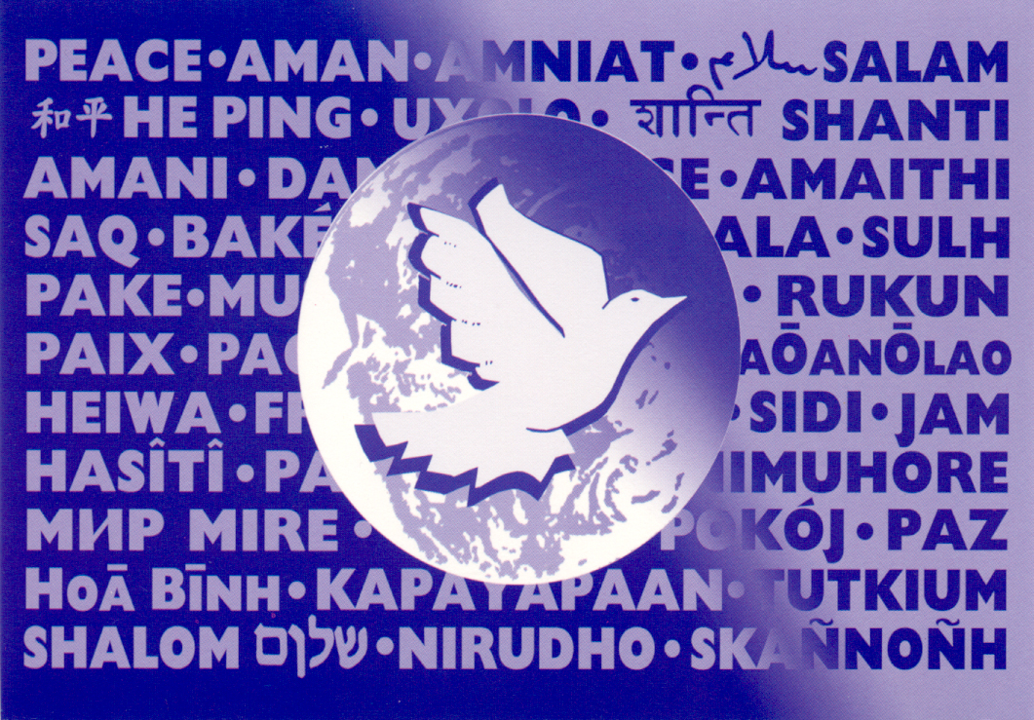

Multi Faith Prayer Service
For Leisure World
and the Surrounding Community

Wednesday, October 18, 2017
6:00 PM

Let all who enter be joined together in a spirit of prayer.
 Please remember to silence your cell phones and electronic devices. 

Where you see an asterisk (*) please stand if you are able.

Words in bold are to read by the congregation.

SILENT MEDITATION

We gather to greet the One who is beyond the reach of thought and speech, and yet by whose grace all speech is possible. We gather seeking the One whom the Vedas describes as neti, neti – not this, not that. We gather to encounter the One whom the sages have called the Source of all Wisdom. We gather to experience the One who is beyond darkness and in whom the veil of doubt and despair are removed. We gather to acknowledge the One who is perfect, ancient, and brings out the best in us. We gather together to meet the One.
- Adopted from Bapu Mahatma Mohandas Gandi (1869-1948)

MEDITATIVE MUSIC Holly Oberle, organist

WELCOME AND INTRODUCTION Rev. Dr. Woodie Rea

LIGHTING OF THE PEACE CANDLE International Prayer for Peace

Lead us from darkness to light, from falsehood to truth;
Lead us from despair to hope, from fear to trust;
Lead us from hate to love, from war to peace;
Let peace fill our heart, our world and our universe.

CALL TO PRAYER Rev. Dr. Ramonia L. Lee

Leader: When peace is shattered and the world is in turmoil,
ALL: We turn our hearts toward our God.

Leader: When hearts are broken and minds are confused,
ALL: We turn our hearts toward our God.

Leader: When words fail and silence is elusive,
ALL: We turn our hearts toward our God.
Leader: When anger rises and hostility accelerates,
ALL We turn our hearts toward our God.
Leader: We gather as children of many traditions,
Inheritors of shared wisdom and great hopes,
ALL: We come collectively as seekers of peace,
And together, we unite our hearts toward God.

INVOCATION
*HYMN OF GATHERING O God, Our Words Cannot Express

O God, our words cannot express,
The pain we feel this day.
Enraged, uncertain, we confess,
Our need to bow and pray.

We grieve for all who lost their lives,
And for each injured one.
We pray for children, husbands, wives,
Whose grief has just begun.

O Lord, we're called to offer prayer,
For all our leaders, too.
May they, amid such great despair,
Be wise in all they do.

We trust your mercy and your grace;
In you we will not fear!
May peace and justice now embrace!
Be with your people here!

A READING FROM THE JEWISH TRADITION Rabbi Dr. Gary Fink

REFLECTION

PRAYER

Bless us our Father, all of us as one, with the light of your countenance. You gave us, Lord our God, the Torah of life and loving kindness, righteousness, blessing, mercy, life and peace. Blessed are you Lord, who blesses us and all nations with peace. May he who makes peace in high places, make peace for us and for all nations and let us say, Amen. Oseh shalom bimromav Hu ya'aseh shalom aleinu V'al kol Haamim V'imru, v'imru amen. Let love and justice flow like a mighty stream. Let peace fill the earth as the waters fill the sea and let us say: Amen. Let us now pray together:

ALL: Let peace fill our heart, our nation, and our world. Amen.

A READING FROM THE ISLAMIC TRADITION Sh. Mohamed Abdullahi

REFLECTION

PRAYER

Bismillah Ar Rahman Ar Raheem (in the name of God who is merciful and beneficent) Allahumma antassalam was minkassalam wa ilaikayarjessalam, hayyena rabbana bissalme wa'adkhilna darassalame tabarakta rabbana wa ta'alaita ya zaljalal-i-walikram. (Oh Allah! You are Peace personified; You are the source of Peace for all other creatures; Peace always turns towards thee. Oh Creator and Sustainer! keep us alive with peace, and let us enter the Home of Peace) Sayings of Prophet Muhammad (peace be upon him) You will not enter Paradise until you believe, And you will not believe until you love one another, And you will not love one another until you promote peace among you.
Let us now pray together:

ALL: Let peace fill our heart, our nation, and our world. Amen.
A READING FROM THE CHRISTIAN TRADITION Sr. Christine Kresho, CSJ

REFLECTION

PRAYER

Gracious God, we give You thanks for your Spirit that is as near to us as our own breath. We thank you for creating us in Your image, and claiming us as Your children. We are all interconnected and belong to You. Remind us that Your love is more powerful than violence and hatred and that Your presence will sustain us as nothing else can. Give us the courage to follow Your ways rather than the ways of this world. Open our hearts to You so that we also may open them to each other. Lead us Lord, on the path of peace. In the name of all who love You, we pray, Amen. Let us now pray together:

ALL: Let peace fill our heart, our nation, and our world. Amen.

HYMN O for a World
O for a world where everyone, respects each other's ways,
Where love is lived and all is done, with justice and with praise.

O for a world where goods are shared, and misery relieved,
Where truth is spoken, children spared, equality achieved.

We welcome one world family, where all will have a choice,
That opens us to unity, and each one has a voice.

O for a world where everyone, can live in hope and peace;
Where time and tears will be no more, and all but love will cease.

A READING FROM THE HINDU TRADITION Swami Atmajnanananda

REFLECTION

PRAYER

Aum sarve bhavantu sukhinah. Sarve santu niramayah. Sarve bhadhrani pashyantu. Maa kaschid dukh bhaagbhave. May all beings be happy. May all beings be healthy. May all beings experience prosperity. May none in the world suffer. Ekam sat vipraha bahudha vadanti Truth is one, the wise call it by many names. Let us now pray together:

ALL: Let peace fill our heart, our nation, and our world. Amen.

A READING FROM THE BUDDHIST TRADITION Rev. Eunju Nam

REFLECTION

PRAYER

Namo Tassa Bhagavato Arahato Samma Sambuddhassa Buddham Saranam Gacchami. Dhammam Saranam Gacchami. Sangham Saranam Gacchami. Homage to him, the Exalted One, the Enlightend One, the Supremely Awakened One. I go to the Buddha for guidance. I go to the Dharma for guidance. I go to the Sangha for guidance. People of the world, parents and children, brothers and sisters, husbands and wives, and other family members and kinsmen, should respect and love each other, refraining from hatred and envy. They should share things with others, and not be greedy and miserly, always speak friendly words with a pleasing smile, and not hurt each other. May all beings be happy and safe
Let us now pray together:

ALL: Let peace fill our heart, our nation, and our world. Amen.
A READING FROM THE UNITARIAN UNIVERSALIST TRADITION Michael Benefiel

REFLECTION

PRAYER

We pray for peace on earth. For peace that is life-giving; for peace that is love-bearing; For peace that is purposeful; for peace that is prevailing. We remember those who are victims of racism, traumatized by violence, changed by terrorism; for those in anguish; those whose lives will never be the same again. May we deepen our desire for peace; restore our resolve for peace; increase our intent to work for peace. Will for us peace, perfect and prevailing. Let us now pray together:

ALL: Let peace fill our heart, our nation, and our world. Amen.

HYMN This Is My Song

This is my song, O God of all the nations,
A song of peace for lands afar and mine;
This is my home, the country where my heart is;
Here are my hopes, my dreams, my holy shrine:
But other hearts in other lands are beating
With hopes and dreams as true and high as mine.

My country's skies are bluer than the ocean,
And sunlight beams on cloverleaf and pine;
But other lands have sunlight too, and clover,
And skies are everywhere as blue as mine:
O hear my song, thou God of all the nations,
A song of peace for their land and for mine.

MEDITATION Rev. Dr. Woodie Rea

*PRAYER OF COMMITMENT Rev. Dr. Ramonia Lee

Leader: We commit ourselves to proclaiming our firm conviction that violence and terrorism are incompatible with the authentic spirit of religion…
People: Hear our prayer.

Leader: We commit ourselves to standing together in solidarity against systemic racism, against the forces of hatred, against acts and language of supremacy, and against oppression experienced on any and all levels…
People: Hear our prayer.

Leader: We commit ourselves to educating people to mutual respect and esteem, in order to help bring about a peaceful coexistence between people of different ethnic groups, cultures and religions…
People: Hear our prayer.

Leader: We commit ourselves to engaging in the difficult conversations and to fostering a culture of dialogue, so that there may be an increase of understanding and respect between individuals and people…
People: Hear our prayer

Leader: We commit ourselves to defending the right of everyone to live a decent life in accordance with their own cultural identity…
People: Hear our prayer. Amen.

*CLOSING HYMN Let There Be Peace On Earth

Let there be peace on earth, and let it begin with me.
Let there be peace on earth, the peace that was meant to be.
With God our creator, family all are we.
Let us walk with each other, in perfect harmony.

Let peace begin with me, let this be the moment now.
With every step I take, let this be my solemn vow;
To take each moment, and live each moment in peace eternally!
Let there be peace on earth, and let it begin with me

A BLESSING IN A TIME OF VIOLENCE Dr. Ramonia L. Lee

Which is to say, this blessing is always.

Which is to say, there is no place this blessing does not long to cry out in lament,
To weep its words in sorrow, to scream its lines in sacred rage.

Which is to say, there is no day this blessing ceases to whisper into the ear
Of the shocked, the terrified, the grieving, the despairing.

Which is to say, there is no moment this blessing refuses to sing itself
Into the heart of the hated and the hateful, the victim and the victimizer,
With every last ounce of hope it has.

Which is to say, there is none that can stop it, none that can silence it,
None that can keep it from springing forth from the mouths of us who hope and
From the hearts of us who love.

Until this blessing has spoken its final word,
Until this blessing has breathed its own benediction in every place, in every tongue.
Hear this blessing today: Peace. Peace. Peace. Go in peace. Amen.

POSTLUDE Holly Oberle, organist

PARTICIPANTS
(According To Order Of Service)

Rev. Dr. Woodie Rea
Senior Minister
The Inter-Faith Chapel

Rev. Dr. Ramonia Lee
Minister of Congregational Life
The Inter-Faith Chapel

Rabbi Dr. Gary Fink
Jewish Residents of Leisure World

Sh. Mohamed Abdullahi
Muslim Community Center of Silver Spring

Sister Christine Kresho, CSJ
Our Lady of Grace Catholic Church

Swami Atmajnanananda
Vedanta Center of Greater Washington DC

Rev. Eunju Nam
Won Buddhism Center of Washington

Michael Benefiel
Leisure World Unitarian Universalist Community

ORGANIST: Holly Oberle

USHERS: Ruth Doherty, Arlene Kaiser, Clydis Kellough, and Joe Parker

Our Special thanks to all our guests, participants, and those who assisted in this service in various ways. Peace, Shalom, Salaam, Pace, Namaste, Shanti, Peace.

