**The Inter-Faith Chapel**

“A House of Prayer for All People”

**Mid-Week Lenten Service**

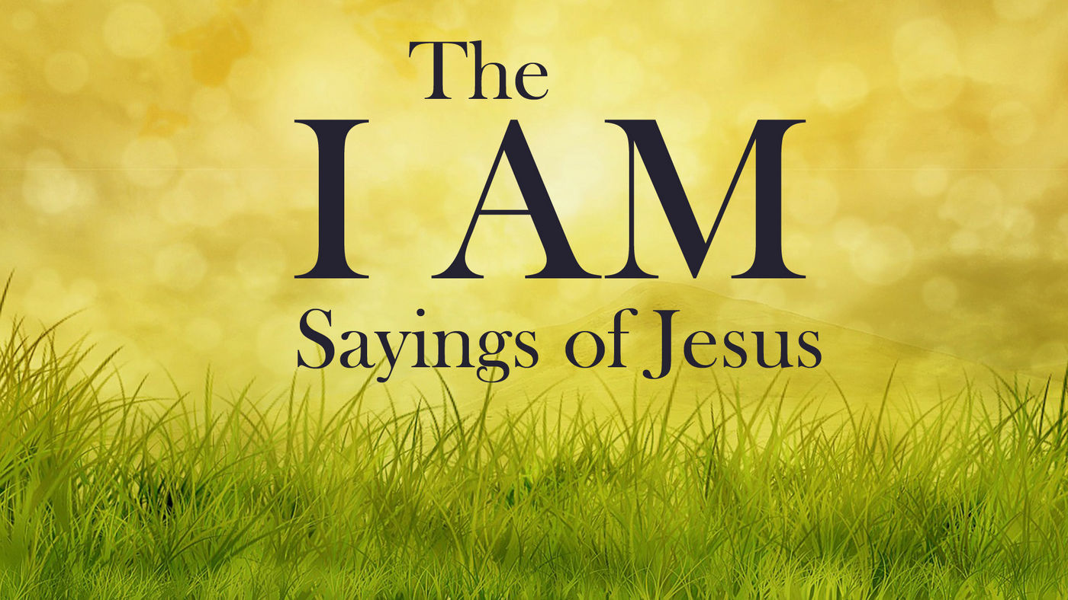

***March 20, 2018***

____________ **MID-WEEK LENTEN WORSHIP SERVICE 12:00 PM**

✞ ***Please enter in silence and use the prelude to prepare yourself for worship.*** ✞

**PRELUDE *Air* Georg Friedrich Handel**

***Grazioso*  Georg Philipp Telemann**

***God’s Time is Best*  Johann Sebastian Bach**

**Holly Oberle, Guest Organist**

**CALL TO WORSHIP** **Dr. Woodie Rea**

*Leader: We have gathered here to continue our journey toward the cross.*

**PEOPLE: We have gathered here to make the Lenten pilgrimage together.**

*Leader: We have gathered here seeking a word of grace.*

**PEOPLE: We have gathered here seeking light amidst darkness.**

*Leader: Rise, shine, for your light has come!*

**PEOPLE: The true Light that enlightens every person has come!**

**ALL: O God, may your light illumine our world, shining love into the dark corners of confusion, fear, and despair.**

**Guide us through these forty days, and lead us now into worship.**

**INVOCATION**

*Jesus said, “I am the light of the world. Whoever follows me will not walk in darkness.” This is the promise of God to whom we now pray.*

**Light of Christ, awaken us this hour to the brilliance of your presence in our midst. Shine among us in such a way that the darkness without, and within, may be pushed back, and the brightness of grace be ushered in. Empower us to move from darkness to light, and from sin to new life. May your light shine through our worship this day. This we pray in the name of the Light, that is the light for all people, Jesus Christ. Amen.**

✞ **HYMN *Longing for Light, We Wait in Darkness (Christ, Be Our Light)***

✞ **You may stand.**

*Music used by permission, CCLI #1683224*

**CALL TO CONFESSION Dr. Ramonia Lee**

It is easier to criticize others than it is to look at our own faults. In the revealing light of God’s love, our failings are illuminated. It is in our confession where we realize our need for God’s purifying light and our hope for God’s abundant mercy. Let us confess the sins of our hearts and the shortcomings of our lives to our Lord who hears and forgives:

**PRAYER OF CONFESSION**

**God of light, we live in the darkness of despair; worried about our own lives, concerned for our own health, fearful for our own safety. We confess that we often place the needs of others in the shadows. We allow threats to familiarity to dim our perspectives. We allow division and hatred to darken our lives. We confess that your light is not always visible to the world through us. God, forgive us. Shine the light of your love upon us. In Jesus name, we pray. Amen.**

***(A period of silent prayer is offered for personal confession)***

**WORDS OF ASSURANCE**

*The light of God’s love shines into the dark places of our world, healing its brokenness, and bringing hope to places of despair. The light of God’s love makes us forgiven people. The light of grace is ours. Thanks be to God. Amen.*

**SCRIPTURE READING John 8: 12-18**

*Leader: The Gospel of the Lord.*

**PEOPLE: Praise to you, O Christ.**

**ANTHEM *Arise, My Soul, Arise* Dan Forrest**

**Women’s Chorus**

**SERMON Rev. Tim Bonner**

**“I Am the Light of the World”**

**PRAYERS OF THE PEOPLE**

*Each petition ends with the following response:*

*Leader: Jesus, Light of the world,*

**PEOPLE: Shine in and through us each day.**

**LORD’S PRAYER UNISON**

**Our Father who art in heaven, hallowed be thy name, thy kingdom come, thy will be done on earth as it is in heaven. Give us this day our daily bread; and forgive us our sins as we forgive those who sin against us. And lead us not into temptation, but deliver us from evil, for thine is the kingdom, and the power, and the glory forever. Amen.**

✞ **CLOSING HYMN *Immortal, Invisible, God Only Wise***

**BENEDICTION**

***As you exit, please leave quietly to respect the continued worship of others.***

***You are invited to stay to meditate and pray for as long as you desire.***

***Go with God and in peace.***

**THOUGHT FOR THE WEEK**

*Learn to light a candle in the darkest moments of your life.*

*Learn to carry a candle into the darkest moments of someone’s life.*

*Be the light that helps others see.*

*Shine the Light of the world; it is what gives life its deepest significance.*

* Roy T. Bennett, [*The Light in the Heart*](https://www.goodreads.com/work/quotes/49604402)



**LENTEN WORSHIP SCHEDULE**

**March 27 “I Am the Door” • John 10:9**

**Rev. Diane Hugger**

**April 3 “I Am the Vine” • John 15:5**

**Rev. Vernice Slade Carney**

**April 10 “I Am the Resurrection and Life” •John 11:25**

**Rev. Dr. Bob Perry**

**USHERS**

**Cloteele Damsky and Louise Langley**

**OUR SOUP & YOUR SANDWICH**

**All are invited to join us for lunch in the Fellowship Hall.**

**Soup has been purchased from the Terrace Room.**

**LENTEN OFFERING**

**Offering Plates are located in The Narthex.**

**The Lenten offering will go toward the outreach ministries**

**of The Inter-Faith Chapel.**

**MITE BOXES FOR THE SOCIETY OF ST. ANDREW**

As part of your spiritual discipline, you may also consider setting aside your loose change every day and placing it in one of the Society of St. Andrew Mite Boxes. When you pick up your mite box from the Narthex resource table, be sure to also take the Lenten devotional material that is available for your personal reflection.

Please return your mite box to the table in the Narthex on Good Friday, April 19.