The Inter-Faith Chapel
“A House of Prayer for All People”

Mid-Week Lenten Service

MOUTH of christ

March 14, 2018

____________ MID-WEEK LENTEN WORSHIP SERVICE 12:00 PM

❖ Please enter in silence and use the prelude to prepare yourself for worship. 

WE GATHER AS THE BODY OF CHRIST

Christ has no body but yours, no hands, no feet on earth but yours.
Yours are the eyes with which he looks compassion on this world,
Yours are the feet with which he walks to do good.
Yours are the hands, with which he blesses all the world.
Yours are the hands, yours are the feet, yours are the eyes, you are his body.
- Teresa of Avila (1515–1582)

PRELUDE
Canon in D Johann Pachelbel
I Call to Thee, Lord Jesus Christ Johann Sebastian Bach
My Faith Looks Up to Thee Karl Osterland

Holly Oberle, Guest Organist

WORDS OF WELCOME Dr. Ramonia Lee

CALL TO WORSHIP

Leader: Open my lips, O Lord,
PEOPLE: And my mouth will give you praise.
Leader: We will lift up our voices to God.
PEOPLE: We will speak words of thanks as long as we live.
Leader: Great is the Lord, and greatly to be praised.
PEOPLE: May the words of our mouths be pleasing to you, O Lord.
ALL: Oh, speak to us, dear Savior, your true and faithful word.
Proclaim to us your favor, let us be thus assured.
O Word made flesh, forever, your name shall be adored.
Oh, let us cherish ever, the mouth of Christ, our Lord.

INVOCATION

 HYMN Lord, Speak to Me That I May Speak

 All who are able, please stand.
Music used by permission, CCLI #1683224

WE EXPERIENCE GOD’S GRACE

CONFESSION AND ASSURANCE OF PARDON Dr. Woodie Rea

Leader: Vocal God, you have spoken to your people throughout the ages and you speak to us still.
PEOPLE: Forgive us when we do not hear your voice.
Leader: Lord, we confess today how difficult it is to tame our tongues.
PEOPLE: Forgive what our mouths are hesitant to name.
Leader: We lay before you, words that we wish we could unspeak, and silence kept when it would have been better to speak,
PEOPLE: We confess our double talk, all the talk behind backs, every confidence broken, every wound that our words have inflicted.
Leader: We confess that we use our voice to distance ourselves from others that are different from us, rather than using our mouths to speak the good news of your love.
PEOPLE: Help us to think before we speak, guide us to use our words to build up rather than tear down, help our tongues to lead us to maturity and faithfulness.
Leader: Lord, use our mouths, to bring about harmony, healing, and reconciliation. Use our voices as prophets, that others may hear
Your voice. Hear us now our silent prayers…

(A period of silent prayer is offered for personal confession)

Leader: God speaks to us with grace and mercy.
From God’s mouth, to our ears,
The good news is ours:
We are loved, we are accepted, we are forgiven.
PEOPLE: Thanks be to God!

WE HEAR GOD’S WORD

SCRIPTURE READING Luke 4: 14-22

Leader: The Gospel of the Lord.
PEOPLE: Praise to you, O Christ.

ANTHEM God So Loved the World Sir John Stainer
Women’s Chorus

SERMON “THE MOUTH OF CHRIST” Rev. Ernie Poland

WE RESPOND IN FAITH

PRAYERS OF THE PEOPLE

Each petition ends with the following response:

Leader: Let us pray to the Lord;
PEOPLE: Lord, speak the word and it shall be.

LORD’S PRAYER UNISON

Our Father who art in heaven, hallowed be thy name, thy kingdom come, thy will be done on earth as it is in heaven. Give us this day our daily bread; and forgive us our sins as we forgive those who sin against us. And lead us not into temptation, but deliver us from evil, for thine is the kingdom, and the power, and the glory forever. Amen.

WE DEPART RENEWED

 CLOSING HYMN A Year of God’s Favor

BENEDICTION

The Lord bless you and keep you.
The Lord speak graciously and tenderly to you.
The Lord breathe his Spirit upon you, and give you peace. Amen.

As you exit, please leave quietly to respect the continued worship of others.
You are invited to stay to meditate and pray for as long as you desire.
Go with God and in peace.

THOUGHT FOR THE WEEK
The mouth of Christ, our brother,
Still speaks from heaven above,
As we address each other,
With Spirit-given love.
May we, such grace receiving,
Become, with one accord,
In all our daily living,
The Body of the Lord.

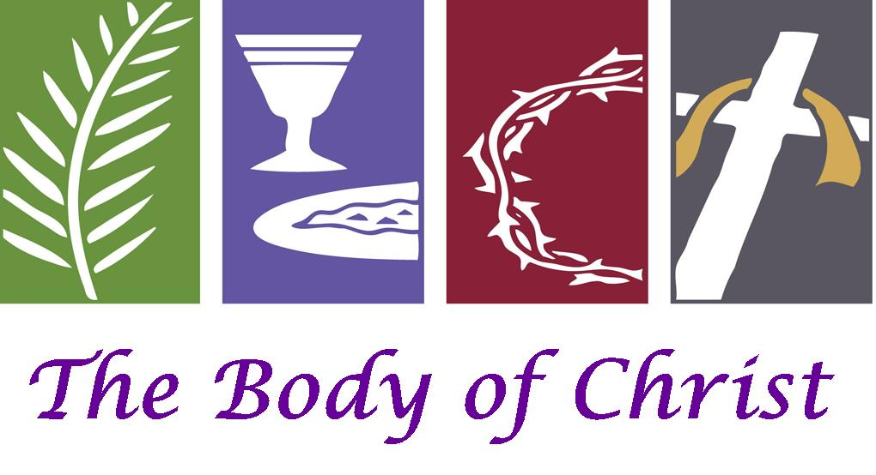

LENTEN WORSHIP SCHEDULE

March 21 “The Heart of Christ” • John 11: 17-44
Rev. Barbara McKenzie

USHERS

Cloteele Damsky and Clydis Kellough

OUR SOUP & YOUR SANDWICH

All are invited to join us for lunch in the Fellowship Hall.
Soup has been purchased from the Terrace Room.

LENTEN OFFERING

Offering Plates are located in the narthex.
All offerings from the mid-week Lenten service and the mite boxes will be given to The Potato Project of The Society of St. Andrew.

MITE BOXES FOR THE SOCIETY OF ST. ANDREW

As part of your spiritual discipline, you may also consider setting aside your loose change every day and placing it in one of the Society of St. Andrew mite boxes. When you pick up your mite box from the narthex resource table, be sure to also take the Lenten devotional material that is available for your personal reflection.

Please return your mite box to the table in the narthex on Good Friday, March 30th.

