**The Inter-Faith Chapel**

**“A House of Prayer for All People”**

**3680 South Leisure World Blvd.**

**Silver Spring, Maryland 20906**

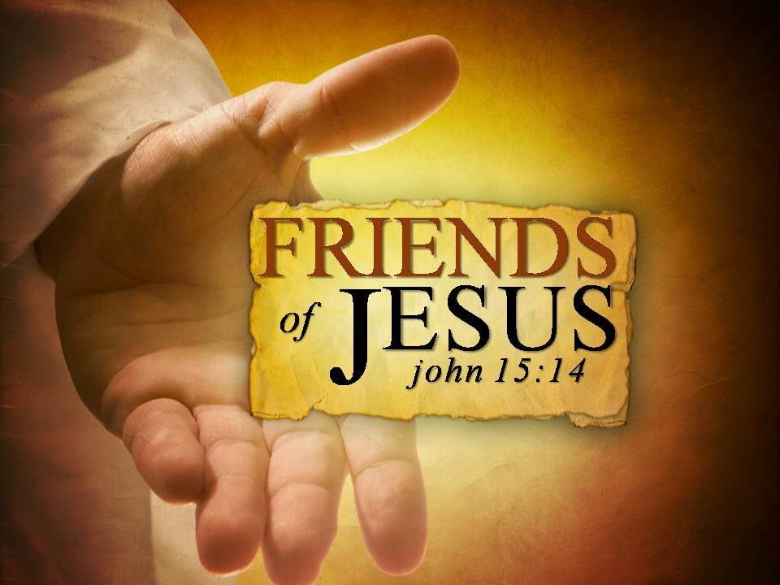

**May 6, 2018**

**Sixth Sunday of Easter**

**Holy Communion**

**9:00 AM Worship Service 11:00 AM**

** *As you enter to worship, please remember to silence your cell phones.* **

**SILENT MEDITATION**

*A friend is one who walks in when the rest of the world walks out. Never above you. Never below you. Always beside you. -* Walter Winchell

**WORDS OF WELCOME Dr. Ramonia Lee**

**LIGHTING THE PEACE CANDLE**

**We light this candle as a symbol of our ongoing commitment to *peace* in our world.**

**PRELUDE *Prelude and Fuge in E Minor (Cathedral)* J. S. Bach**

**Kevin M. Clemens, Director of Music**

**CALL TO WORSHIP (**Based on Psalm 98)

*Leader*: *Come, sing to the Lord a new song!*

**PEOPLE:** **Let us remember all the wonderful things God has done!**

*Leader:* *Make a joyful noise to God, all the earth!*

**PEOPLE:** **Let us lift our voices in praise and shout with happiness!**

Leader: *Here today, you will find love, freely available to all.*  
**PEOPLE:**  **We give thanks for God’s inclusive and unconditional love.**  
*Leader: Here today, you will find relationship, fully accepting us as we are.*

**PEOPLE: We give thanks for our personal and meaningful friendship with Jesus.**

**ALL: Let our worship today make a joyful noise,**

**Rejoicing in the friendship of God.**

** HYMN *What A Friend We Have in Jesus***

**INVOCATION**

** All who are able, please stand.**

*Music used by permission, CCLI #1683224*

**CALL TO CONFESSION**

**PRAYER OF CONFESSION UNISON**

**Jesus, our constant companion and eternal friend, you call us into relationship and teach us to live in your generous love. We instead, often walk away from our neighbors in need, wrapped up in our own concerns. We struggle to accept others into our lives. We do not view the stranger as a potential friend. We fail to love others as you have loved us. Receive our confession, forgive our unfriendly ways, and give us grace to live together in harmony with others and to live in unity with you. Hear us as we pray. Amen.**

**WORDS OF ASSURANCE**

** AFFIRMATION OF FAITH The Apostles Creed**

**I believe in God, the Father almighty, creator of heaven and earth. I believe in Jesus Christ, his only Son, our Lord. He was conceived by the power of the Holy Spirit and born of the Virgin Mary. He suffered under Pontius Pilate, was crucified, died, and was buried. On the third day he rose again. He ascended into heaven and is seated at the right hand of the Father. He will come again to judge the living and the dead. I believe in the Holy Spirit, the holy universal church, the communion of saints, the forgiveness of sins, the resurrection of the dead, and life everlasting. Amen.**

** GLORIA PATRI**

**Glory be to the Father, and to the Son, and to the Holy Ghost;**

**As it was in the beginning, is now, and ever shall be;**

**World without end. Amen. Amen.**

**SCRIPTURE READING Psalm 98 OT 678**

**Readers 9:00 AM Tronette Anochie**  **11:00 AM Bernice Williams**

**ANTHEM *The Garden Hymn* David W. Music**

**Chancel Choir**

**SCRIPTURE READING John 15: 9-17 NT 134**

**SERMON “You’ve Got a Friend in Me” Dr. Woodie Rea**

**INVITATION TO THE OFFERING**

**OFFERTORY *I Have Longeth for Thy Saving Health (Psalm 119)* William Byrd**

**Chancel Choir**

**DOXOLOGY (Tune: Lasst Uns Erfreuen)**

**Praise God from whom all blessings flow;**

**Praise God, all creatures here below;**

**Alleluia! Alleluia!**

**Praise God, the source of all our gifts!**

**Praise Jesus Christ, whose power uplifts!**

**Praise Spirit, Holy Spirit!**

**Alleluia! Alleluia! Alleluia!**

** PRAYER OF DEDICATION**

**COMMUNION HYMN  *Here, O Our Lord, We See You***

**INVITATION TO HOLY COMMUNION**

*Leader: Through Jesus, we confirm that God knows us, cherishes us, and loves us.*

**PEOPLE: Through Jesus, we know that we are called as friends.**

*Leader: Let us come to this table, not because we must, but because we may.*

**PEOPLE: Let us sit together in humility and harmony,**

**rather than in pride or with anger.**

*Leader: Let all who are hungry for the love of God, come and be fed.*

**PEOPLE: Let all who are thirsty for new life, come and share the cup.**

**ALL: Let all who want to follow Jesus, come and join the feast.**

**COMMUNION PRAYER UNISON**

**Gracious God, may this meal be for us an encounter with your presence as we break this bread and drink of this cup. May the sharing of this food be a taste of the joyful relationship we have with you, and with others. Send your Holy Spirit upon us, that this meal may be holy and that we may all be one. Hear us as we continue to pray…**

**THE LORD’S PRAYER SUNG BY ALL**

**Our Father who art in heaven, hallowed be thy name, thy kingdom come, thy will be done on earth as it is in heaven. Give us this day our daily bread; and forgive us our debts as we forgive our debtors. And lead us not into temptation, but deliver us from evil, for thine is the kingdom, and the power and the glory forever. Amen.**

**THE WORDS OF INSTITUTION**

**SHARING THE BREAD AND CUP**

**PRAYER AFTER COMMUNION UNISON**

**Amazing God, thank you for your presence in this place. We thank you for giving us a taste of our kinship with you, and with others, through this meal. May this food strengthen us to be your joyful and hopeful friends. Flow through us, living and healing God. Through Jesus Christ we pray. Amen.**

** PASSING THE PEACE**

** HYMN *Called as Partners in Christ’s Service***

** BENEDICTION**

** CONGREGATIONAL RESPONSE Tune: Ar Hyd Y Nos**

**Text: Jaroslav Vajda**

**“Go, my children, with my blessing, never alone.**

**Waking, sleeping, I am with you, you are my own.**

**In my love’s baptismal river I have made you mine forever.**

**Go, my children, with my blessing, you are my own.”**

**POSTLUDE *Easter Concerto in A Minor* J. S. Bach / A. Vivaldi**

**Kevin M. Clemens, Director of Music**

**PARTING THOUGHT**

*You've got a friend in me,  
You've got a friend in me.  
You’ve got troubles, I’ve got them too,  
There isn't anything I wouldn't do for you,  
We stick together, and we can see it through,  
'Cause you've got a friend in me,  
Yes, you've got a friend in me.* - Randy Newman

**HOLY COMMUNION** is provided two different ways at The Inter-Faith Chapel.

You are invited to participate in the form most familiar and comfortable to you.



**COMMUNION is served in the PEWS** on the

LEFT SIDE of the sanctuary facing the cross.

Wafers and individual ***grape juice*** cups will be passed

in trays among the congregation.

**COMMUNION is served by INTINCTION** on the

RIGHT SIDE of the sanctuary facing the cross.

Communicants will come forward down the center aisle

and receive a wafer to dip in the chalice of ***wine***.

**COMMUNION STEWARDS**

**9:00 AM Clydis Kellough and Millie Spencer**

**11:00 AM George and Ginger Samara**

**Heidi Bender and Jill Glixon**

**COMMUNION ASSISTANTS**

**9:00 AM** **Vivian Williams**

**11:00 AM Ann Burke**

**CHOIR COMMUNION SERVERS**

**Marian Cain-Hayden and Maureen Harris**

**SERVING COMMUNION IN THE PEWS**

**9:00 AM Tronette Anochie, Betty Hughes**

**Robert Lagas, Claudette Warner-Milne**

**11:00 AM Judy Duarte, Louise Langley**

**Marlys Moholt, Renee Ward-Anderson**

**Welcome To The Inter-Faith Chapel**

**We are committed to being “*A House of Prayer for All People*.”**

**We are seeking to share the Love of God through caring, outreach, study, and worship. We invite you to share with us in this journey.**

**We are delighted you are here today, and hope you will return soon and often!**

**Believing in God whose love and grace are accessible to all,**

**we strive to make our worship service accessible to all.**

**For V isually I mpaired Large Print Bibles are available**



**For H earing I mpaired Sound Enhancement Headphones**

**For P hysically I mpaired Wheelchair Accessible Seating**

**Automated Doors are available at front and side entrances**

**If you need help with any of these aids, please ask an usher for assistance.**

**ALTAR FLOWERS Dedicated by Larry Pusey in memory of his wife**

**Charlotte**

**FLOWER MAKERS Ann Burke and Marlys Moholt**

**USHERS 9:00 AM Clydis Kellough, Head Usher**

**Lola Neill, Ralph Sheaffer, Lois Smith**

**USHERS 11:00 AM John Moens, Head Usher**

**Arlene Kaiser, Georgiana Jones, Melvin Robinson**

**GREETERS 9:00 AM Sandra Broadhurst**

**11:00 AM Loraine Rieks**

**Delivery of Altar Flowers on Monday, May 7**

**Beryl Adams   Tyra Thompson**

**Presence on Sunday, April 29**

**9:00 AM 77  11:00 AM 140  Total 217**

|  |  |
| --- | --- |
| **April 29 Offering**  **$3,717** | **Weekly Budget Need**  **\*$8,173** |
| **Year to Date Offering**  **$131,268** | **Year to Date Budget Need**  **\*$138,941** |

*This amount represents offerings received and pledge budget only and does not reflect approved withdrawal of $11,698 per month from the endowment fund needed to meet overall 2018 budget.

***ANNOUNCEMENTS & OPPORTUNITIES***

**GREETING TO VISITORS** We extend a special welcome to you and hope that you will return to be with us again soon. We would appreciate having a record of your attendance today. Please sign the *Visitor Register* located in the narthex and be sure to pick up an Inter-Faith Chapel coffee mug as our small gift. Also, please make your presence known to one of our pastors, we would enjoy being in conversation with you. Thank you for coming!

**NEW MEMBER / AFFILIATE REGISTER** If you are interested in joining The Inter-Faith Chapel, please let us know by signing the *Member / Affiliate Register* located near the coat room in the narthex. We will be in touch with you to joyfully welcome you into the full fellowship of this congregation.

**BOOKS FOR KIDS** The Committee for the Homeless and Working Poor is sponsoring their annual *Books for Kids* drive to benefit the children of Georgian Forest Elementary School. New and gently used books may be dropped off in the Narthex from **May 1 – May 15**. You may also make a donation by writing a check to The Inter-Faith Chapel with the notation *Books for Kids* in the memo line and all funds will be distributed to the school.

**BEDDING COLLECTION** The Missions Committee is sponsoring a bedding drive for A Wider Circle on **Monday, May 7 and Tuesday, May 8** between 10:00 am and 2:00 pm. Needs include bed sheet sets of any case, pillow cases, blankets, spreads, coverlets, towels and washcloths. All items need to be in good condition with no stains or tears. Drop-offs can be made at the portico in front of The Chapel.

**HOLY LAND TOUR IN MAY 2019** Dr. Lee is planning a group trip to the Holy Land, leaving on May 24, 2019 for a ten day trip to many Biblical sites. The trip will require extensive walking and the cost is $3,448 per person. If you would like more information, you are invited to attend an information session on **Tuesday, May 15** at 10:00 am. Please RSVP by calling 301-598-5312 by May 9.

**CAPITAL WIND SYMPHONY** Please join us for the **Sunday, May 20** Inter-Faith Concert featuring the Capital Wind Symphony, over 50 brass, woodwind and percussion instrumentalists. Invite your friends, family and neighbors to attend the 3:00 pm concert. A reception will follow and a free will offering will be taken to support the concert series. Tickets are not required.

**POTLUCK PICNIC AT WHEATON REGIONAL PARK** All are invited to join the *Born 1942* *and After* group for a potluck picnic on **Tuesday, June 5** from 1:00 pm – 3:30 pm. The Chapel will provide hamburgers, hot dogs, chips, paper supplies and beverages, and each person is asked to bring a dish to share. Sign up in the Narthex or at [www.inter-faithchapel.org](http://www.inter-faithchapel.org). Payment of $8.00 per person is due by May 27.

**BOOK CLUB** You are invited to join the *Born 1942 and After* group for a book club discussion on **Wednesday, June 20** at 7:00 pm. *The Light Between Oceans* by Margot L. Stedman is the story of a lighthouse keeper and his wife in 1918 Australia who make one devastating choice that forever changes two worlds. If you would like The Chapel to order the book for you, RSVP by Thursday, May 24 at [www.inter-faithchapel.org](http://www.inter-faithchapel.org) or by calling 301-598-5312. The cost of the book is $11.00. If you will get your own copy of the book, RSVP by Thursday, June 14. Snacks and beverages will be provided and donations accepted to cover the cost.

**IN PRAISE OF AGE** Each year, we honor all our members and friends who are 90 years old or older. Mark your calendars for our *In Praise of Age* services on **Sunday, June 24**. If you are 90 years old or will celebrate your 90th birthday in 2018, call the office at 301-598-5312 to make sure you are one of the honorees.

***ON THE TOWN* AT THE OLNEY THEATRE** The *Born 1942 and After* group invites all to attend *On The Town* at the Olney Theatre on **Wednesday, July 18** at 2:00 pm. Call 301-598-5312 or go to [www.inter-faithchapel.org](http://www.inter-faithchapel.org) to register. Cost is $45 per person payable by check to NARFE Chapter 1143. RSVP and payment are due no later than Monday, June 25.

**CHAPEL CALENDAR**

**Monday, May 7 10:00 AM - Bedding Drive for A Wider Circle**

**2:00 PM**

**1:00 PM Sermon on the Mount Bible Study**

**2:00 PM Sandwich Makers**

**Tuesday, May 8 10:00 AM - Bedding Drive for A Wider Circle**

**2:00 PM**

**10:30 AM Brooke Grove Worship**

**12:00 PM Staff Meeting**

**Wednesday, May 9 10:00 AM Women’s Chorus**

**10:00 AM Bedford Court Worship**

**Thursday, May 10 9:30 AM Finance Committee**

**11:00 AM - Extended Staff Meeting**

**3:00 PM**

**7:00 PM Chancel Choir**

**Friday, May 11 10:00 AM Knitting**

**THE INTER-FAITH CHAPEL**

**3680 South Leisure World Blvd.**

**Silver Spring, MD 20906**

[**www.inter-faithchapel.org**](http://www.inter-faithchapel.org)

**CHAPEL OFFICE HOURS**

**9:00 AM - 3:00 PM  Monday – Friday**

**301-598-5312**

***Rev. Dr. Woodie Rea, Senior Minister***

***Rev. Dr. Ramonia Lee, Minister of Congregational Life***

***Kevin M. Clemens, Director of Music***

***Linda Faith, Administrator/Facilities Manager***

***Bonnie Bonner, Administrative Secretary***

***Steve Buck, Gary Carpenter, Video Technicians and Sextons***