The Inter-Faith Chapel
“A House of Prayer for All People”

3680 South Leisure World Blvd.
Silver Spring, Maryland 20906

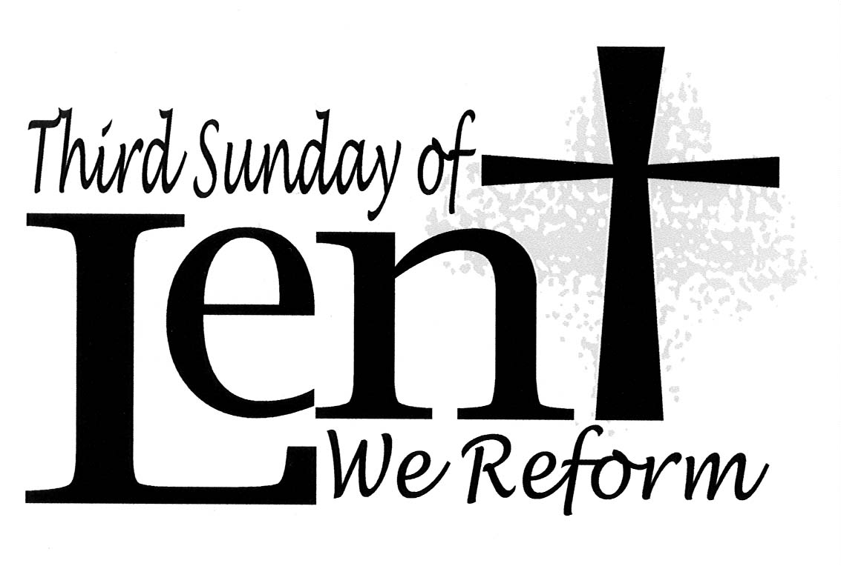

March 15, 2020
Third Sunday in Lent

10:00 AM Worship Service ________

 As you enter to worship, please remember to silence your cell phones. 

SILENT MEDITATION

May the shelter of God embrace you in difficult moments. May the well of God refresh you in dry moments. May the dance of God play in your joyful moments. May the peace of God be with you in all your moments on the journey of life.
- Joyce Rupp in Out of the Ordinary

WORDS OF WELCOME Dr. Woodie Rea

LIGHTING THE PEACE CANDLE

We light this candle as a symbol of our ongoing commitment to peace in our world.

PRELUDE Prelude on “Aberystwyth” Gordon Young
Kevin M. Clemens, Director of Music

CALL TO WORSHIP Dr. Ramonia Lee

Leader: God, who created the heavens and the earth knows our needs.
PEOPLE: Lord, come and quench our thirst.
Leader: We come, drinking frequently from the well of fear and doubt.
PEOPLE: We have drawn deeply from those waters.
Leader: We come, familiar with the well of anger and hate.
PEOPLE: These waters flourish in our land.
Leader: Lord, bring us to the water of peace and hope.
PEOPLE: Lord, bring us to the well of salvation.
ALL: Let us open our hearts, our spirits, our souls to the Living Water.
Let us worship God together.

 HYMN Guide Me, O Thou Great Jehovah

INVOCATION

        Those who are able are invited to stand

Music used by permission, CCLI #168324
CALL TO CONFESSION

KYRIE

PRAYER OF CONFESSION UNISON

God of all places, we confess that we have often turned from you and wandered in our own parched land of fear and doubt. Our thirst mounts daily and we can often think of nothing but our own satisfaction. Lord of living water, pour your mercy on us. Move us from the dryness of selfishness and stubbornness to the refreshment of hope and peace. Lead us from the drought of division and differences, to the well of love and grace available to all. Heal us, merciful God and quench our thirst with the living water. Amen.

WORDS OF ASSURANCE

 AN AFFIRMATION OF FAITH

We believe in the triune God, Father, Son, and Holy Spirit,
Who gathers, nurtures, and cares for the church through Word and Spirit.

We believe in one holy, universal church, the worldwide communion of saints, called from the entire human family.

We believe that unity is both a gift and an obligation for the church of Jesus Christ.

We believe that the sin of division, separation, and hatred between people and groups is harmful, and we commit ourselves to resisting such disunity.

We believe that Jesus is Lord, the Living Water, the Bread of Life.

As the church, we are the salt of the earth. We are the light of the world.

To God be the honor and the glory for ever and ever. Amen.

- From the Belhar Confession
 GLORIA PATRI

Glory be to the Father, and to the Son, and to the Holy Ghost;
As it was in the beginning, is now, and ever shall be,
World without end. Amen. Amen.

FIRST READING John 4: 5–26 NT 115

Scripture Reader: Claudette Milne

ANTHEM Woman in the Night Brian Wren/Alfred Fedak
Men’s Chorale

MORNING PRAYER

LORD’S PRAYER UNISON

Our Father who art in heaven, hallowed be thy name. Thy kingdom come, thy will be done, on earth as it is in heaven. Give us this day our daily bread. And forgive us our sins as we forgive those who sin against us. And lead us not into temptation, but deliver us from evil. For thine is the kingdom, and the power and the glory, forever. Amen.

SECOND READING John 4: 27–42 NT 115

HYMN Jesus, Lover of My Soul

SERMON “Know Your Place” Dr. Woodie Rea

INVITATION TO OFFERING

OFFERTORY Healer of Our Every Ill Marty Haugen
Men’s Chorale

DOXOLOGY (Tune: Old Hundredth)

Praise God, from whom all blessings flow;
Praise Him, all creatures here below;
Praise Him above, ye heavenly host;
Praise Father, Son, and Holy Ghost. Amen.

 PRAYER OF DEDICATION

 PASSING OF THE PEACE

Leader: May the peace of Christ be with you.
PEOPLE: And also with you.
Leader: We lift up our hearts to the Lord
PEOPLE: It is good to give God our thanks and praise.
Leader: May the peace which passes understanding be with you
PEOPLE And keep our hearts and minds in Christ Jesus. Amen.

 CLOSING HYMN Glorious Things of Thee Are Spoken

 BENEDICTION RESPONSIVE

Leader: Go now from this service of worship
to the service of God’s people near and far;

PEOPLE: Let us be refreshed by the living water that Jesus offers.

Leader: Listen for the parched voices of the least of these;
search out the dry places and the arid souls;

PEOPLE: Let us become for them a spring of living water.

Leader: And as you go, may the blessings of
the God of life, the Christ of love, and the Spirit of grace
be upon you this day and forevermore. Amen

 CONGREGATIONAL RESPONSE Tune: Ar Hyd Y Nos
Text: Jaroslav Vajda

“Go, my children, with my blessing, never alone.
Waking, sleeping, I am with you, you are my own.
In my love’s baptismal river I have made you mine forever.
Go, my children, with my blessing, you are my own.”

POSTLUDE Lenten Fugue in C Minor Felix Mendelssohn
Kevin M. Clemens, Director of Music

PARTING THOUGHT

Go in peace,
And may God's love, God's grace, and God's truth,
Be poured out endlessly upon you.
May they well up in you like a stream.
May they flow forth from you like a river.
May they bring abundant growth and beauty to you,
And abundant praise and glory to God’s name.

– Francis Jammes

Welcome To The Inter-Faith Chapel

We are committed to being “A House of Prayer for All People.”

We are delighted you are here today, and hope you will return often!

We are seeking to share the love of God through caring, outreach, study, and worship. We invite you to share with us in this journey.

Believing in God whose love and grace are accessible to all,
we strive to make our worship service accessible to all.

For V isually I mpaired Large Print Bibles are available
For H earing I mpaired Sound Enhancement Headphones
For P hysically I mpaired Wheelchair Accessible Seating

Automated Doors are available at front and side entrances

If you need any assistance during the worship service, please ask an usher.

ALTAR FLOWERS In memory of our beloved son, Rafaa Bashir from
Claudette and Emile Milne and siblings

USHERS Ramon Czujko, Head Usher
Maureen Harris, Yolanda Hunt, Marlys Moholt

GREETER Quinton Hugger

FLOWER MAKERS Anne Dobbs and Aggie Eastham

Delivery of Altar Flowers on Monday, March 16

Beryl Adams  Bruce Gibbs

Presence on Sunday, March 8
132
March 8 Offering  $7,555 | Weekly Budget  $8,462
Year to Date Offering  $77,872 | Year to Date Budget  $84,620

ANNOUNCEMENTS & OPPORTUNITIES

VISITOR / NEW MEMBER REGISTER If you are visiting with us today, we extend a special welcome to you and are so pleased you chose to worship with us. Please sign the Visitor Register located in the narthex and pick up an Inter-Faith Chapel coffee mug as our small gift of welcome and appreciation. Also, if you are looking for a church home and would like to learn more about this vibrant and active congregation, please let us know by signing the Member / Affiliate Register. We are glad you are with us today and hope you will come back soon!

CORONAVIRUS RESPONSE The current rise in concern regarding the spread of the Coronavirus is one that we are all taking seriously. Several modifications to our worship service are being introduced, along with suspending select activities.

A decision regarding the cancelation of worship services on March 22 and March 29 will be announced following Council consideration.

Please read the pastoral letter, “A Statement Towards a Faithful And Approriate Response” included in today’s bulletin for information on how the Inter-Faith Chapel is responding to this situation.

Based on advice from public health experts regarding the increased risk and effect of community transmission among vulnerable populations, the decision has been made to cancel the following programs and events:

TAIZÉ WORSHIP SERVICE The Taize Service has been cancelled for today and will be rescheduled at a later date.

MID-WEEK LENTEN WORSHIP The Mid-Week Lenten Services and “Our Soup Your Sandwich” lunch have been cancelled for the remainder of the series.

LENTEN STUDY The Sermon on the Mount Bible Study series has been cancelled.

CENTERING PRAYER: A LENTEN PRACTICE The Centering Prayer Class has been cancelled. Participants are encouraged to practice Centering Prayer at home.

EASTER FLOWERS Please place your orders for Easter lilies, white mums, and pink hydrangeas that will adorn the Sanctuary as we celebrate our Lord Jesus Christ’s resurrection on Easter Sunday. Flowers may be dedicated in honor or in memory of a loved one. Please return order forms (available in the Narthex) to The Chapel office with your payment, no later than April 1. You may also call the office to reserve your flower or place your order on our web site at www.inter-faithchapel.org The Easter plant that you order is yours to take home following the second service on Easter Sunday!

SHEPHERD’S TABLE PANTRY ITEM DONATIONS Pantry items are being collected today in the Narthex and items may be brought to the Chapel through Thursday, March 19th. Examples of non-perishable pantry items include: canned vegetables, hot sauce, coffee, powdered coffee creamer, sugar, artificial sweeteners, salad dressings, broths (vegetable, chicken, beef), cereals, wheat pasta, brown rice, quinoa, lentils, dry beans, and spices (salt, pepper, onion powder, garlic powder, Italian seasoning). Please check expiration dates before donating. Thank you for your continuing support of Shepherd’s Table!

CHAIR YOGA The final “Body and Brain Chair Yoga” class will be held on Friday, March 27th from 11:00 am – 11:45 am. The class focuses on gentle movements that make fewer demands on balance and strength. It is offered for free and is led by Chapel member Christine Tetrault. Please call 301-598-5312 to be added to the class.

HOLY WEEK MOVIE On Wednesday of Holy Week, April 8 at 1:00 pm join us for a viewing of King of Kings in the Fellowship Hall. The film will be shown in the Fellowship Hall. All are welcome and there is no need for reservations.

BOOK CLUB: DEAR EDWARD The Book Club will gather on Friday, April 24 at 2:00 pm to discuss Dear Edward by Ann Napolitano. No RSVPs are necessary.

A Statement Towards A Faithful And Appropriate Response

The recent rise and spread of the respiratory disease, Coronavirus, (or COVID-19 as designated by the World Health Organization) is cause for concern for all of us. The Inter-Faith Chapel is taking this situation seriously, along with our responsibility to do all we can to safeguard our members, guests, and staff. We are seeking to stay current with public health information and guidelines and to follow the best practices for hygiene, caution, and care.

At such times, we are reminded of how interconnected our global world can be and how important it is to approach one another with compassion and care. We sometimes focus on the numbers and the maps, yet we are reminded that each reported case of the virus has behind it a person, a family, and a community. As a faith community, we are called to be in prayer for those affected, those caring for the affected, and for those valiantly working in international partnerships to respond to this virus.

A global health crisis such as this can be fertile ground for fearful reactions. We must remain informed and develop faithful and appropriate responses. We must be attentive not to place blame on particular individuals or communities. Let our response be centered in compassion and care rather than fear or division.

The well-being of all who enter The Inter-Faith Chapel is our ultimate concern. To this end, we will be implementing the following preventive and cautionary actions in the best interest of our community:

- Washing your hands is one of the most effective deterrents to the spread of this virus. Two hand sanitization stations are available (one in the Narthex, one in the Fellowship Hall). Additional hand sanitizer bottles are located throughout The Chapel. Please do not remove these so that all may benefit from their use.
- Our custodial team is taking extra measures in their cleaning of surfaces and populated areas to ensure that our facilities are as clean as possible and prepared to receive you.
- Linger Longers – Our coffee and conversation time in the Fellowship Hall following worship services will be temporarily suspended.
- Mid-week “Our Soup, Your Sandwich” – The soup lunch immediately following Mid-Week Worship services has been discontinued.
- Passing of the Peace – During this portion of our worship service, we will share in a written responsive blessing rather than traditionally turning to greet and shake hands or embrace others.
- Holy Communion – We will be modifying our method of serving communion to be more centralized and limit touching. Congregants on both sides of the Sanctuary will be invited to come forward where trays of individual cups (grape juice on one side and wine on the other) will be available.
- Exiting Worship – The traditional greeting line by the ministers in the Narthex will be altered. Ministers will always be available following worship services for pastoral conversation and special greetings, however, it is asked that handshakes and hugs be restrained during this time.
- Pastoral Care – We recognize that some facilities have implemented visitation restrictions. Please call the Chapel Office to let us know of those who may be admitted to a local hospital.
- If you are feeling ill or have recently experienced cold or flu-like symptoms, please stay home and consult your physician. If you decide to not attend worship due to illness, you may stay connected to The IFC by viewing that Sunday’s service on Leisure World Channel 972. A DVD of past services can also be provided upon request. Additionally, offertory giving is available at www.inter-faithchapel.org, through mail, or by contacting The Chapel office.

We recognize that these precautions may seem difficult to some, and be different for many others, but we ask for your understanding and indulgence as we all journey through this challenge together.

We are committed to coming together in worship and other gatherings of our faith community as conditions allow. Discussions are underway regarding the potential cancelation of worship services if this seems the most caring and appropriate response. Please be assured the staff and leadership of The IFC are continuing to monitor news and developments and will assess the need for more changes as warranted. As always, please call The Chapel Office at 301-598-5312 if you have questions about whether a meeting or event is cancelled or for any other concerns.

Prayers for health and wholeness during this time, and always.

- Rev. Dr. Woodie Rea
Senior Minister

CHAPEL CALENDAR

Monday, March 16 10:00 AM Centering Prayer
2:00 PM Sandwich Makers

Tuesday, March 17 10:30 AM Lenten Bible Study
12:00 PM Staff Meeting
12:15 PM Ratner Museum (meeting time)
1:30 PM Handbells
6:30 PM Gospel Choir Rehearsal

Wednesday, March 18 10:30 AM Women’s Chorus
12:00 PM Lenten Service
3:00 PM Alzheimer’s Support

Thursday, March 19 10:30 AM Missions Committee
4:00 PM Dance Practice
7:00 PM Chancel Choir

* Events that have been struck through have been cancelled out of an abundance of caution regarding community transmission of Coronavirus

THE INTER-FAITH CHAPEL

3680 South Leisure World Blvd.
Silver Spring, MD 20906
www.inter-faithchapel.org

CHAPEL OFFICE HOURS

9:00 AM - 3:00 PM  Monday – Friday
301-598-5312

Rev. Dr. Woodie Rea, Senior Minister
Rev. Dr. Ramonia Lee, Minister of Congregational Life
Kevin M. Clemens, Director of Music
Bonnie Bonner, Administrator
Joy Dufour, Administrative Assistant
Steve Buck, Gary Carpenter, Video Technicians and Sexton

