The Inter-Faith Chapel
"A House of Prayer for All People"
3680 South Leisure World Blvd
Silver Spring MD 20906

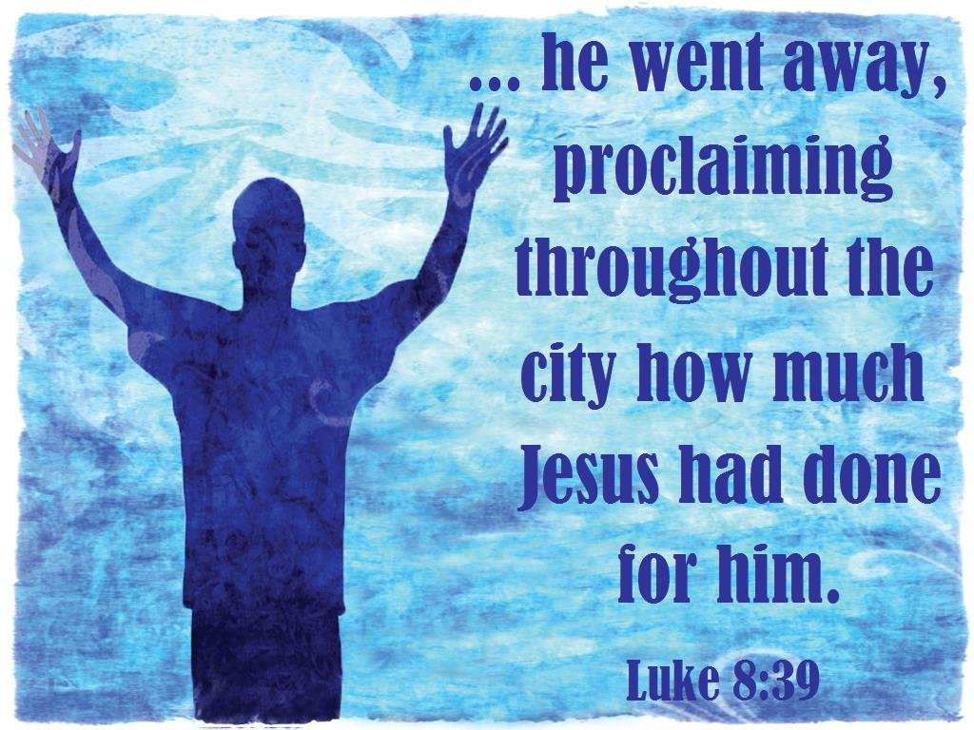

June 30, 2019

Third Sunday After Pentecost

9:00 AM Worship Service 11:00 AM

 As you enter to worship, please remember to silence your cell phones. 

SILENT MEDITATION

God of Peace, bless this gathering of your people. Help us listen to the still, small voice within us, that we might make peace with ourselves. Help us listen to each other, that we might make peace between us. Help us listen for Your voice, that we might find peace in You. - Rumi

WORDS OF WELCOME Dr. Ramonia Lee

LIGHTING THE PEACE CANDLE

We light this candle as a symbol of our continuous commitment toward the efforts of peace and harmony in our world.

PRELUDE Arioso in the Ancient Style James H. Rogers
Judith Daffer, Guest Organist

CALL TO WORSHIP

Leader: Come, all whose souls thirst for the living God.
PEOPLE: We come in search of help and hope.

Leader: Come, all who are acquainted with loss and grief.
PEOPLE: We come bringing our tears, our wounds, and our cares.

Leader: Come, all who are in need of good news.
PEOPLE: We come in search of joy, peace, and light.

Leader: Come, and find refuge in the sanctuary of God.
PEOPLE: We come to experience the One who is our help and our hope.

ALL: Come one, come all!
Come, let us worship God! Based on Psalm 42

INVOCATION

 HYMN Guide Me, O Thou Great Jehovah

 You may stand in body or in spirit.
Music used by permission, CCLI #1683224
CALL TO CONFESSION

PRAYER OF CONFESSION UNISON

We confess, O God, that we often find ourselves distracted by a legion of voices that make untrue claims and offer false promises. We believe safety and security resides in ample bank accounts. We think that success leads to real happiness. We equate power with dominating others. We hold fast to anger in order to reciprocate. We feed our hunger for love and approval with food that does not satisfy. O God, break us from the hold of these claims that bind us, and free us to live the life you offer. Amen.

WORDS OF ASSURANCE

 AFFIRMATION OF FAITH

Leader: Let us stand as we are able and unite in an affirmation of faith.
ALL: I believe in the Living God, the joy of the universe,
Who is the pulse and purpose of all things seen and unseen.

I believe in the Creator God, who clothes the wild flowers and dresses all of creation with beauty and goodness.

I believe in Jesus the Christ, God’s true Son,
Who took upon himself the healing of the human race,
Who was betrayed, crucified, dead and buried in a borrowed tomb.
Who on the third day was found to be gloriously alive, and
Who calls those who trust in him to serve in this world.

I believe in the Holy Spirit of God, within and among all,
Who brings hope out of despair, healing out of illness,
Love out of apathy, and joy out of sorrow.

I believe in God,
The Source of abundance,
The Revelation of grace and truth, and
The Presence of Power and Love. Amen.

GLORIA PATRI

Glory be to the Father, and to the Son, and to the Holy Ghost;
As it was in the beginning, is now, and ever shall be,
World without end. Amen. Amen.

SCRIPTURE READING Psalm 42: 1-5 OT 633

Readers 9:00 AM Sharon Lee  11:00 AM Bob Blair

ANTHEM The King of Love My Shepherd Is Harry Rowe Shelley
Women’s Chorus

MORNING PRAYER

LORD’S PRAYER UNISON
Our Father who art in heaven, hallowed be thy name. Thy kingdom come, thy will be done, on earth as it is in heaven. Give us this day our daily bread. And forgive us our sins as we forgive those who sin against us. And lead us not into temptation, but deliver us from evil. For thine is the kingdom, and the power and the glory, forever. Amen.

SCRIPTURE READING Luke 8: 26-36 NT 82

HYMN Jesus, Thy Boundless Love to Me

SERMON “What Are Our Possessions” Dr. Woodie Rea

INVITATION TO OFFERING

OFFERTORY Lord, Make Us Worthy Natalie Sleeth
Women’s Chorus

DOXOLOGY (Tune: Lasst Uns Erfreuen)

Praise God from whom all blessings flow;
Praise God, all creatures here below;
Alleluia! Alleluia!
Praise God, the source of all our gifts!
Praise Jesus Christ, whose power uplifts!
Praise Spirit, Holy Spirit!
Alleluia! Alleluia! Alleluia!

 PRAYER OF DEDICATION

 PASSING THE PEACE

 HYMN This Is My Song

 BENEDICTION

Leader: Go forth into the world with hope,

PEOPLE: For nothing can bind, restrict, or contain
the healing life Christ offers each of us.

Leader: Go, and make room for quiet, still places
amidst the chaos of everyday life,

PEOPLE: For there we will find God.

Leader: Go, and dare to proclaim all that God has done for you,

PEOPLE: For there are many who need our good news.

Leader: Go, knowing that the light of God shall lead you,
The presence of Christ shall guide you,
And the power of the Holy Spirit shall uphold you,
This day and always.

PEOPLE: Amen.

 CONGREGATIONAL RESPONSE Tune: Ar Hyd Y Nos
Text: Jaroslav Vajda

“Go, my children, with my blessing, never alone.
Waking, sleeping, I am with you, you are my own.
In my love’s baptismal river I have made you mine forever.
Go, my children, with my blessing, you are my own.”

POSTLUDE Cortege Gordon Young
Judith Daffer, Guest Organist

PARTING THOUGHT
God be your comfort, your strength.
God be your hope and support.
God be your light and your way.
God be your constant companion. - Anglican Church of New Zealand

Welcome To The Inter-Faith Chapel

We are committed to being “A House of Prayer for All People.”

We are seeking to share the Love of God through caring, outreach, study, and worship. We invite you to share with us in this journey.

We are delighted you are here today, and hope you will return soon and often!

Believing in God whose love and grace are accessible to all,
we strive to make our worship service accessible to all.
For V isually I mpaired Large Print Bibles are available
For H earing I mpaired Sound Enhancement Headphones
For P hysically I mpaired Wheelchair Accessible Seating
Automated Doors are available at front and side entrances

If you need help with any of these aids, please ask an usher for assistance.

ALTAR FLOWERS Dedicated in memory of Dr. Robert Barnett by his
wife Carolyn

USHERS 9:00 AM Clydis Kellough, Head Usher
Maureen Harris, Yolanda Hunt, Ralph Sheaffer

USHERS 11:00 AM Louise Langley, Head Usher
Arlene Kaiser, Bertie Knisely, Tyra Thompson

GREETERS 9:00 AM Robert and Mary Reid
11:00 AM Ruth Witt

FLOWER MAKERS Patty Elton and Maggi Lindley

Delivery of Altar Flowers on Monday, July 1
Beryl Adams  Heidi Bender

Presence on Sunday, June 23
9:00 AM 90  11:00 AM 120  Total 210

June 23 Offering  $7,520 | Weekly Offering Budget  $8,173
Year to Date Offering  $212,829 | Year to Date Offering Budget  $204,325

ANNOUNCEMENTS & OPPORTUNITIES

GREETING TO VISITORS We extend a special welcome to you and hope that you will return to be with us again soon. We would appreciate having a record of your attendance today. Please sign the Visitor Register located in the narthex and be sure to pick up an Inter-Faith Chapel coffee mug as our small gift. Also, please make your presence known to one of our pastors, we would enjoy being in conversation with you. Thank you for coming!

NEW MEMBER / AFFILIATE REGISTER If you are interested in joining The Inter-Faith Chapel, please let us know by signing the Member / Affiliate Register located near the coat room in the Narthex. We will be in touch with you to joyfully welcome you into the full fellowship of this congregation.

MEMORY ACADEMY This 4-week course, plus 3 optional booster classes, provides memory improvement techniques. The class will meet on Mondays, starting July 1 from 10:00 am – noon, and there is a registration fee. Pick up a flyer in the Narthex or read the announcement in the June Courier. Register by calling Holy Cross Health at 301-754-8800.

FILMS OF FAITH: PAUL, APOSTLE OF CHRIST Join us this summer for Films of Faith on the 2nd Tuesday of each month at 1:00 pm. Each inspirational selection has a challenging and uplifting message. You are welcome and are encouraged to bring a friend to our next movie on Tuesday, July 9 at 1:00 pm. No tickets or registration are required. Paul, Apostle of Christ is the story of Luke who risks his life to visit Paul, held prisoner in Rome. Paul has survived so much – floggings, a shipwreck, starvation, stoning, hunger, thirst, cold and exposure- and is haunted by the shadows of his past misdeeds. Both men struggle to live out the Gospel of Jesus Christ and spread their message to the world.
GET HEALTHY Do you want to maximize your enjoyment of your retirement years? If so, consider joining us for a 5-part series Get Healthy this summer. You may pick up a flyer in the Narthex to view the list of topics. The seminars will be held on Wednesdays in July and August from 1:00 – 2:15 pm in The Inter-Faith Chapel Fellowship Hall. Sign up for each class by calling the Chapel office at 301-598-5312 or going to the Announcements section of www.inter-faithchapel.org. Sign up by the Friday prior to each class.

DAY TRIP TO WASHINGTON, DC The Inter-Faith Fellowship invites everyone to see three different sites in Washington, DC: the gardens at the Franciscan Monastery, Lincoln’s Cottage where the first family spent three summers of his presidency, and Fort Stevens, part of the Civil War Defenses of Washington. The group will gather at The Chapel on Thursday, July 18 at 8:30 am to carpool. This trip requires extensive walking and standing. Volunteer drivers are necessary to make this trip possible. RSVP by calling 301-598-5312 or going to www.inter-faithchapel.org where you may scroll down to the Announcements section and click on the picture. Your RSVP and non-refundable payment of $12.50 per person for the guided tour of Lincoln’s Cottage are due no later than Thursday, July 11.
ICE CREAM SOCIAL All are invited to come and enjoy our annual ice cream social, with live music, on Tuesday, July 23 at 1:30 pm. No tickets or registration are needed. Just come to enjoy a cold treat, lively music, and warm fellowship. This event is sponsored by Outreach and Fellowship Committee.
Our entertainers will be George Spicka and Alice Schlothauer. They have performed together numerous times over the past 15 years, from intimate settings to big band concerts. Alice's experience as a front-person and her command of a wide variety of tunes, insure a fun time at all informal gatherings. George is not only an accomplished composer and pianist, he also can sing a variety of pop tunes.
CHRISTMAS CRAFTS Each year, Chapel members and friends contribute their time and talent to make homemade craft items for Christmas gift bags for those who live in nursing care facilities. If you enjoy making crafts, please put Tuesday, July 30 at 11 am on your calendars to plan for Christmas gift bags. Bring a sample of your craft item.

CHAPEL CALENDAR

Monday, July 1 10:00 AM Memory Academy
2:00 PM Sandwich Makers

Tuesday, July 2 12:00 PM Staff Meeting

Wednesday, July 3 3:00 PM Alzheimer’s Support

Thursday, July 4 Office closed

Friday, July 5 7:30 PM JRLW Shabbat

THE INTER-FAITH CHAPEL

3680 South Leisure World Blvd.
Silver Spring, MD 20906

www.inter-faithchapel.org

CHAPEL OFFICE HOURS

9:00 AM - 3:00 PM  Monday – Friday

301-598-5312

Rev. Dr. Woodie Rea, Senior Minister
Rev. Dr. Ramonia Lee, Minister of Congregational Life
Kevin M. Clemens, Director of Music
Bonnie Bonner, Administrator
Steve Buck, Gary Carpenter, Video Technicians and Sextons

