**The Inter-Faith Chapel**

“A House of Prayer for All People”

3680 South Leisure World Blvd.

Silver Spring, Maryland 20906

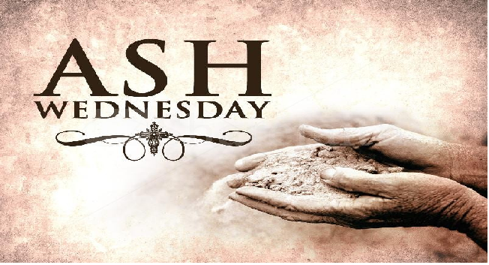

***February 14, 2018***

***Holy Communion***

_____________**ASH WEDNESDAY WORSHIP SERVICE 12:00 PM**

*** ** As you enter to worship, please remember to silence your cell phones.* **

**SILENT MEDITATION**

*With today’s service, we begin a forty-day journey toward Easter. Through this journey we dedicate ourselves to the spiritual disciplines of self-examination, confession, and penitence. The Imposition of Ashes is a traditional sign of humility and repentance, reminding us that God’s grace overcomes sin, God’s love overcomes death, and God’s presence is with us through all of life’s journeys.*

**WORDS OF W`ELCOME Dr. Woodrow Rea**

**PRELUDE: *Agnus Dei* Samuel Barber**

**Kevin M. Clemens, Director of Music**

**CALL TO WORSHIP** **Dr. Ramonia L. Lee**

*Minister: Return to the Lord your God;*

**PEOPLE: For God is gracious.**

*Minister: Confess to the Lord your God;*

**PEOPLE: For God is merciful.**

*Minister: Repent to the Lord your God;*

**PEOPLE: For God is slow to anger.**

*Minister: Praise the Lord your God;*

**PEOPLE: For God abounds in steadfast love.**

*Minister: Worship the Lord your God.*

**PEOPLE: Together, let us worship God!**

**✝ HYMN**  ***Take Time to Be Holy***

**✝ INVOCATION**

**✝** Those who are able are invited to stand

*Music used by permission, CCLI #1683224*

**SCRIPTURE READING** **Psalm 51: 1-12**

**ANTHEM** ***Go Not Far From Me, O God* Nicholas Zingarelli**

**Chancel Choir**

**GOSPEL READING** **Matthew 6:1-6, 16-21**

**SERMON** **“What God Can Do With Dust”**

**INVITATION TO THE OFFERING**

**OFFERTORY *Savior of the World* John Goss**

**Chancel Choir**

**✝ DOXOLOGY Old Hundredth**

**Praise God from whom all blessings flow;**

**Praise Him, all creatures here below;**

**Praise Him above, ye heavenly host:**

**Praise Father, Son and Holy Ghost. Amen.**

**✝ PRAYER OF DEDICATION**

**COMMUNION HYMN *Be Known to Us in Breaking Bread***

**INVITATION TO THE TABLE**

**COMMUNION PRAYER UNISON**

**Gentle God, we thank you for your Lenten walk through Galilee and our lives. We thank you for your open welcome and healing grace. We thank you for the miracle of reconciliation and for this supper of Passion that makes us whole. We now place the ashes of our humanity and the brokenness of our lives on this Table of grace so that the bread might make us whole and the cup might fill us with hope. Hear us as we continue to pray...**

**THE LORD’S PRAYER SUNG BY ALL**

**Our Father who art in heaven, hallowed be thy name, thy kingdom come, thy will be done on earth as it is in heaven. Give us this day our daily bread; and forgive us our debts as we forgive our debtors. And lead us not into temptation, but deliver us from evil, for thine is the kingdom, and the power and the glory forever. Amen.**

**THE WORDS OF INSTITUTION**

**SHARING THE BREAD AND CUP**

**PRAYER AFTER COMMUNION UNISON**

**O God, as we have been reminded of our frailty, we have pondered what it means to come from dust and to return to dust. As we have been nurtured through this Holy Feast, we have been reminded of the new life available to us through Christ. In the next forty days, renew our spirits as your resurrection people. Amen.**

**SERVICE OF ASHES**

*Ash Wednesday invites us to consider the dust of the earth and to wonder at the gift of life - my life, our life. These ashes were once leaves and branches and places where life was lived to its fullest. Once they were full of life, now they are dry and grey. But mixed with the waters of our baptism and the healing ointment of the gospel, they are symbols of life over death and grace over our sinful nature. These are ashes worth wearing. May we accept this gift, and be blessed.*

**PRAYER OVER THE ASHES**

**IMPOSITION OF ASHES**

Those who desire to receive ashes are invited to come forward.

The Ministers will sign you with ashes saying,

“*Remember that you are dust, and to dust you shall return.*”

**CALL FOR PENITENCE**

*With awkwardness, we come together with ashes on our heads. Each day we try to convince ourselves that we are good and in need of nothing. Let us take forty days to look hard at our so-called goodness and see what it covers up. Then, we will join together in walking with Jesus and following his example. Let us now, join together in our prayer of penitence and confession:*

**PRAYER OF CONFESSION UNISON**

**O God, when we pause to ponder our lives on this Ash Wednesday, we realize that our deepest need is for forgiveness. We often convince ourselves that we are more right or righteous than what is truth. Forgive us, O God, for turning sackcloth into a fashion statement and for turning ashes into a symbol of piety. Guide us and direct us through this Lent season and all days. Amen.**

**WORDS OF MERCY AND RECONCILIATION**

*Remember that you are dust and to dust you shall return. Let the experience of your incomplete humanity awaken you to the wonders, joys, sorrows, and fullness of life. Let the ashes you wear be the ashes of change and transformation in the Spirit. Believe that you are fearfully and wonderfully made in the image of the One who is, and was, and ever more shall be. Amen.*

**✝ HYMN** *We Rise Again from Ashes*

**BENEDICTION**

Holy God, through the discipline of these forty days, teach us what You can do with dust. Lift us from the dying embers of our inattention, mark us with the sign of your holy passion, and make us ready to respond to the call of Jesus Christ.

Marked by a cross on our foreheads,

Empowered by God in our hearts,

Led by the Spirit in our lives,

We make our commitment to the Lenten journey.

In the name of the Father, Son, and Holy Spirit. Amen.

*P****lease depart the sanctuary in silence.***

**USHERS**

**Clydis Kellough and Cloteele Damsky**

**COMMUNION ASSISTANTS**

**Elizabeth Brooks-Evans and Yvonne Williams**

*The Missions Committee encourages you to take a coin box as you leave the service today and, with each meal you enjoy during Lent, join with The Society of St. Andrew in feeding America’s hungry children and adults..*

