**The Inter-Faith Chapel**

**“A House of Prayer for All People”**

**3680 South Leisure World Blvd.**

**Silver Spring, Maryland 20906**

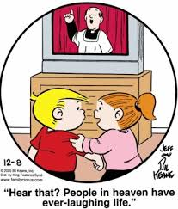

**April 8, 2018**

**Holy Humor Sunday**

**Second Sunday of Easter**

**9:00 AM Worship Service 11:00 AM**

***As you enter to worship, please silence your cell phones.***

**SILENT MEDITATION**

*"Blow the trumpets, shake the tambourine, hear the music, dance! We praise God! Let the praise break forth in the most unlikely places and in silly ways. Let the laughter be deep, for we are God's people." -* Arthur Gafke

**WORDS OF WELCOME Dr. Woodie Rea**

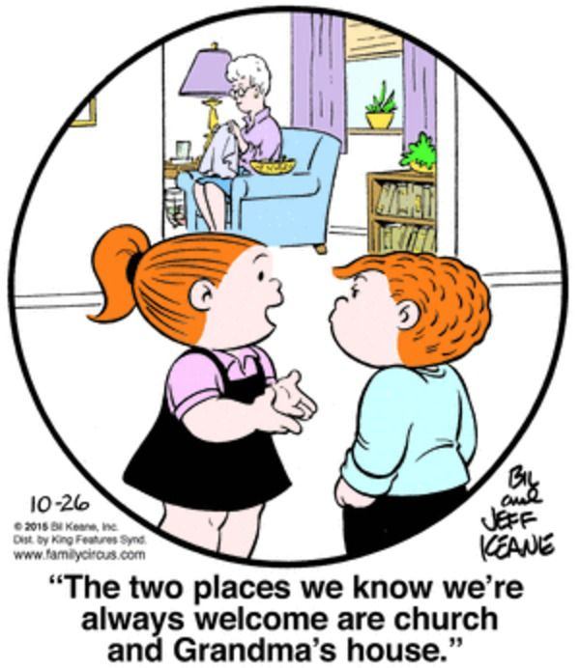

**LIGHTING THE PEACE CANDLE**

**We light this candle as a symbol of our desire for *joy* and *peace* for all.**

**PRELUDE *This Joyful Eastertide* Michael Burkhardt**

**Kevin M. Clemens, Director of Music**

**CALL TO JOYFUL WORSHIP Dr. Ramonia Lee**

*Leader: We come to worship God, who made us in His image.*

**PEOPLE: We live, we love, we laugh, because we are like Him.**

*Leader: We come believing that Jesus Christ is risen.*

**PEOPLE: He had the last laugh over death and darkness.**

*Leader: Come and let us celebrate with holy humor!*

**PEOPLE: Let us shout joyfully to the Lord, our God!**

*Leader: Let us laugh, let us dance,*

**PEOPLE: Let us be happy before the Lord!**

**ALL: Let us worship the Lord with gladness.**

**Let us delight with pleasure before the Lord.**

** HYMN** ***Joyful, Joyful, We Adore Thee***

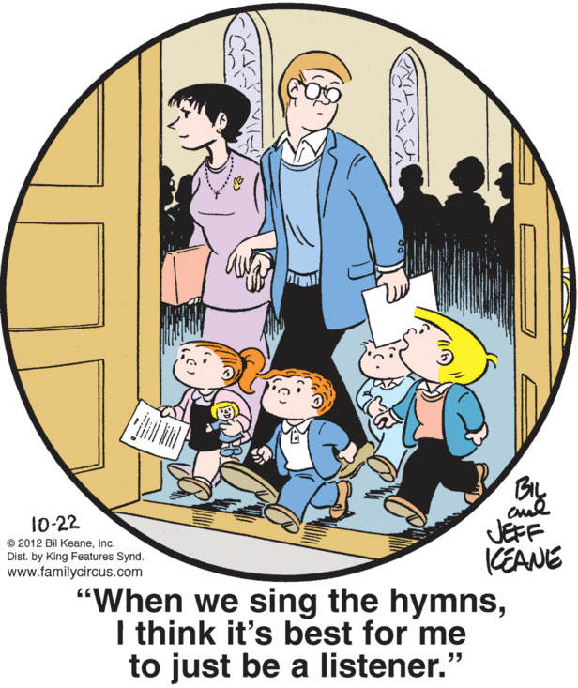

**INVOCATION**

**CALL TO CONFESSION**

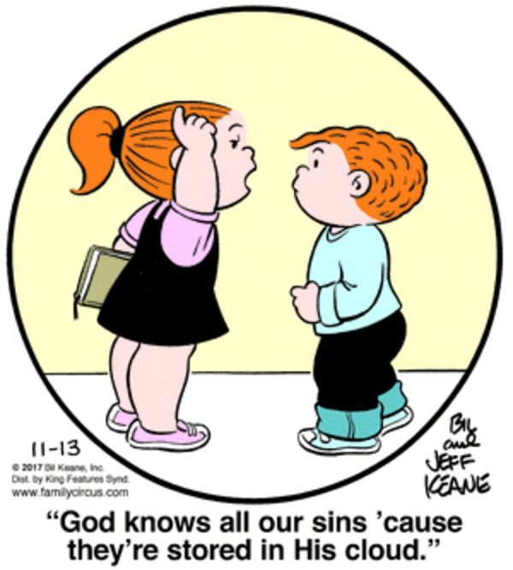

**PRAYER OF CONFESSION UNISON**

**God of Joy, what important people we believe we are. Thinking that we have to be serious all the time, we miss out on much joy in your creation. Forgive us, Lord, when we take ourselves too seriously. Be patient with us when we don’t claim the happiness that is available to us in life. Forgive us, and make us open to the surprising and amusing ways in which you work. Fill us with Easter's laughter. Fill us with your healing joy. Fill us with the love poured into us through Jesus Christ, our Lord and Savior. Amen.**

**WORDS OF ASSURANCE**

** AN AFFIRMATION OF FAITH**

*Leader:* *Let us stand as we are able, and give voice to things we believe:*

**PEOPLE: We believe in an amazing God,**

**Who surprises us on Easter morning**

**Who has the last laugh on evil,**

**Who never gives up loving and working for our good.**

**We believe in the risen Christ,**

**Not stuck in a tomb of despair,**

**Not nailed to a dead end future,**

**Not buried in the past, but alive with us today.**

**We believe Jesus enjoyed friends and festivities.**

**Jesus wept. Jesus laughed.**

**He had the last laugh on the devil**

**When He rose from the dead.**

**We believe in the Holy Spirit,**

**The invisible Presence,**

**The Divine wind of joy, hope, and possibility.**

**We often experience a sense of Spirit with a sense of humor.**

**We believe that God is the Source of laughter.**

**We believe that nothing can separate us from**

**The joy, laughter, and love of Christ. Amen.**

** GLORIA PATRI**

**Glory be to the Father, and to the Son, and to the Holy Ghost;**

**As it was in the beginning, is now, and ever shall be,**

**World without end. Amen. Amen.**

**SCRIPTURE READING Psalm 133 OT 706**

**Readers 9:00 AM Juanita Sealy-Williams**  **11:00 AM Marie Powell**

**JOYFUL REFLECTION *Walk Around Heaven All Day* Patti La Belle**

**Generational Joy Dancers**

**MORNING PRAYER**

**LORD’S PRAYER UNISON**

**Our Father who art in heaven, hallowed be thy name. Thy kingdom come, thy will be done, on earth as it is in heaven. Give us this day our daily bread. And forgive us our sins as we forgive those who sin against us. And lead us not into temptation, but deliver us from evil. For thine is the kingdom, and the power and the glory, forever. Amen.**

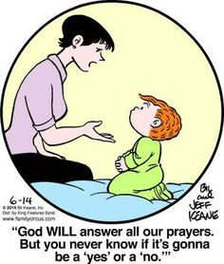

**SCRIPTURE READING John 20: 19-29 NT 140**

**HYMN  *In the Garden***

**SERMON “The Last Laugh” Dr. Woodie Rea**

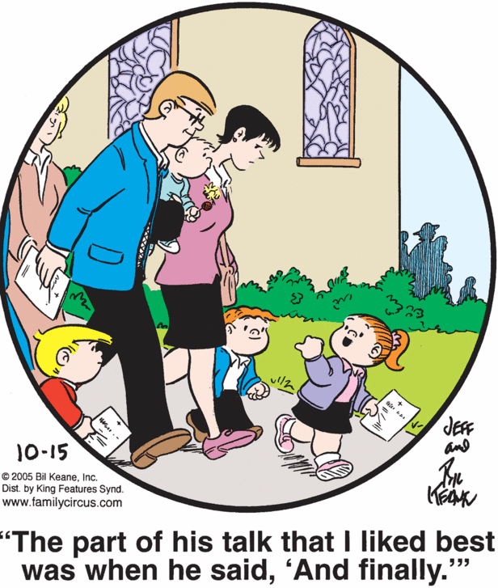

**INVITATION TO OFFERING**

**OFFERTORY *Now the Green Blade Riseth*  Michael Burkhardt**

**Kevin M. Clemens, organist**

** GLORY TO GOD (Tune: Lasst Uns Erfreuen)**

**Praise God from whom all blessings flow;**

**Praise God, all creatures here below;**

**Alleluia! Alleluia!**

**Praise God, the source of all our gifts!**

**Praise Jesus Christ, whose power uplifts!**

**Praise Spirit, Holy Spirit!**

**Alleluia! Alleluia! Alleluia!**

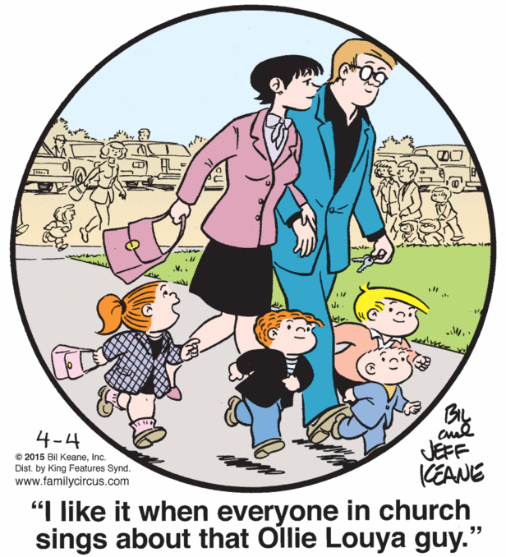

** PRAYER OF DEDICATION**

** PASSING OF THE PEACE AND JOY**

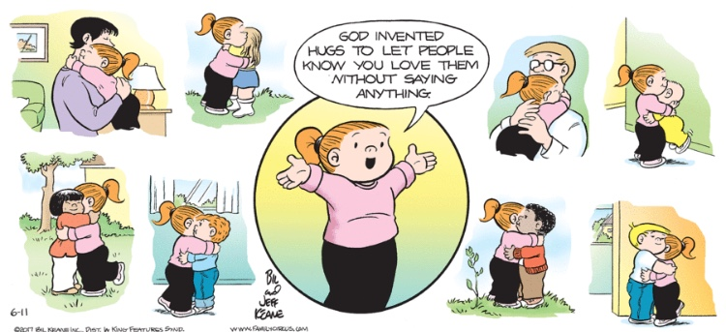

** CLOSING HYMN *Christ Arose***

** BENEDICTION**

*Leader: The God of Laughter called us together*

*So we could share in the laughter of life.*

**PEOPLE: The God of Joy sends us out,**

**To carry the joy of life to the world.**

*Leader: May the God of surprises bring smiles and joys*

*To the everyday and ordinary.*

**PEOPLE: May the God of love**

**Be seen in all we do and say.**

**ALL: Let us go forth to live, to love, to laugh,**

**And may the Spirit of Joy be with us now and forever.**

**Amen.**

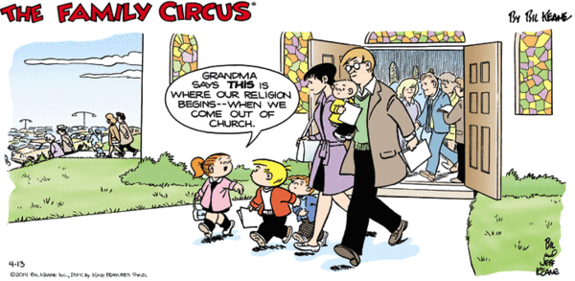

** JOYFUL RESPONSE**

**I’ve got the joy, joy, joy, joy  
Down in my heart, down in my heart, down in my heart,  
I’ve got the joy, joy, joy, joy  
Down in my heart, Down in my heart to stay.**

**(Repeat)**

**POSTLUDE *Grand Choir Dialogue* Eugene Gigout**

**Kevin M. Clemens, organist**

**A PARTING THOUGHT**

*A joyful heart is good medicine, but a crushed spirit dries up the bones.*

Proverbs 17:22

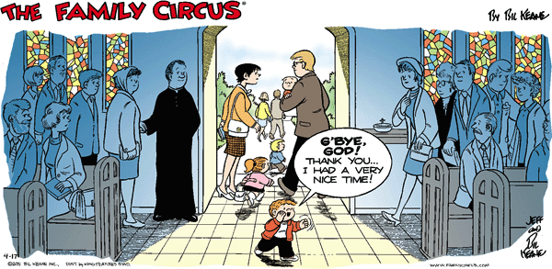

**Holy Humor Sunday: A Brief History**

We at The Inter-Faith Chapel, along with many congregations around the world, recognize the important, but often overlooked, sacred gifts of laughter and joy!

*Holy Humor Sunday,* (also known as *Bright Sunday, Laughter Sunday, Renewal Sunday, Hilarity Sunday,*) has a long and rich history in a number of different Christian traditions.

The celebrations were rooted in the writings of early church theologians (such as Augustine, Gregory of Nyssa, and John Chrysostom) that the resurrection of Jesus from the dead was “God’s supreme joke played on death.”

Churches in 15th century used to celebrate Easter Monday and the Sunday after Easter as *Risus Paschalis*(‘God’s Joke,’ or ‘the Easter laugh’). These days were observed by the faithful as “days of joy and laughter” with festivities, funny stories, and food to celebrate Jesus’ resurrection.

Designating and designing a Sunday service to celebrate God’s gift of laughter and joy may be a new concept for many of us. By doing so, we are in fact, participating in an ancient tradition of the Church and are proclaiming that God has the last laugh!

**Welcome To The Inter-Faith Chapel**

**We are committed to being “*A House of Prayer for All People*.”**

**We are seeking to share the Love of God through caring, outreach, study, and worship. We invite you to share with us in this journey.**

**We are delighted you are here today, and hope you will return soon and often!**

**Believing in God whose love and grace are accessible to all,**

**we strive to make our worship service accessible to all.**

**For V isually I mpaired Large Print Bibles are available**

**For H earing I mpaired Sound Enhancement Headphones**

**For P hysically I mpaired Wheelchair Accessible Seating**

**Automated Doors are available at front and side entrances**

**If you need help with any of these aids, please ask an usher for assistance.**

**ALTAR FLOWERS Dedicated by Tyra Thompson in memory of her sister**

**Linda Windsor**

**FLOWER MAKERS Mercedes Bautista and Maggi Lindley**

**USHERS 9:00 AM Ralph Sheaffer, Head Usher**

**Cloteele Damsky, Clydis Kellough, Larry Traynham**

**USHERS 11:00 AM Barbara Fisher, Head Usher**

**Arlene Kaiser, Louise Langley, Karen Robinson**

**GREETERS 9:00 AM Ruth Doherty**

**11:00 AM Gwen Raphael**

**Delivery of Altar Flowers on Monday, April 9**

**Heidi Bender   Tyra Thompson**

**Presence on Sunday, April 1**

**9:00 AM 128  11:00 AM 266  Total 394**

|  |  |
| --- | --- |
| **April 1 Offering**  **$15,669** | **Weekly Budget Need**  **\*$8,173** |
| **Year to Date Offering**  **$106,979** | **Year to Date Budget Need**  **\*$106,249** |

*This amount represents offerings received and pledge budget only and does not reflect approved withdrawal of $11,698 per month from the endowment fund needed to meet overall 2018 budget

***ANNOUNCEMENTS & OPPORTUNITIES***

**GREETING TO VISITORS** We extend a special welcome to you and hope that you will return to be with us again soon. We would appreciate having a record of your attendance today. Please sign the *Visitor Register* located in the narthex and be sure to pick up an Inter-Faith Chapel coffee mug as our small gift. Also, please make your presence known to one of our pastors, we would enjoy being in conversation with you. Thank you for coming!

**NEW MEMBER / AFFILIATE REGISTER** If you are interested in joining The Inter-Faith Chapel, please let us know by signing the *Member / Affiliate Register* located near the coat room in the narthex. We will be in touch with you to joyfully welcome you into the full fellowship of this congregation.

**INTER-FAITH CONCERT SERIES** A special concert will feature piano and choral compositions by Chapel member Dr. Charles Garner and guest musicians **today at 3:00 pm**. All are invited to this concert and reception afterwards. Tickets are not required.

**INTER-FAITH WOMEN** All women are invited to the Inter-Faith Women’s meeting held on **Thursday, April 12** at 1:30 pm. A program on flowers of the Bible will be presented and refreshments will feature foods of the Bible. You may sign-up today in the Narthex.

**HOLOCAUST REMEMBRANCE DAY** The annual Holocaust Memorial Service, sponsored by the Leisure World Interfaith Committee, will be held in the **Clubhouse II Auditorium** on **Thursday, April 12**at **2:00 PM**. The Yom Hashoah Service will include readings from various faith backgrounds, a candle-lighting service and the principal speaker, provided by the Holocaust Memorial Museum, will be Holocaust survivor, Esther Starobin. Please contact Dr. Rea for further information.

**SPRING BIBLE STUDY** In April and May, we will gather for a Bible study series using the text *The Message of the Sermon on the Mount* by John R. W. Stott. Chapel member Phyllis Lovett will teach the class which will be offered on Mondays from **April 9 – May 21** at 1:00 pm. Call 301-598-5312 or go to [www.inter-faithchapel.org](http://www.inter-faithchapel.org). The book is available for $12.00.

**WALKING: THE MIRACLE EXERCISE** Terrie Daniels, senior fitness and wellness specialist at Brooke Grove Retirement Village, will present this seminar on **Wednesday, April 18** from 1:00 – 2:15 pm at The Chapel. Learn more about the many health benefits of walking, explore the research, and discover tips to motivate yourself. Register at [www.inter-faithchapel.org](http://www.inter-faithchapel.org) or call 301-598-5312 by April 13.

**PIZZA AND MOVIE NIGHT** On **Friday, April 20** at 6:30 pm, the *Born 1942 and* *After* group invites all to enjoy pizza and watching the movie, *Wonder*. This movie presents the story of a boy born with facial differences and shares his extraordinary journey. The cost for dinner is $7.00 which includes pizza, beverages and dessert. Sign up at [www.inter-faithchapel.org](http://www.inter-faithchapel.org) or by calling 301-598-5312. Your RSVP and nonrefundable payment are due by Sunday, April 15.

**BABY SHOWER FOR INTERFAITH WORKS** The Leisure World Committee for the Homeless and Working Poor is sponsoring a baby shower. Interfaith Works needs newborn diapers, clothes for babies up to 3 months old, onesies, blankets, wash clothes, and diaper bags. Drop these items off at **Clubhouse** **I** on **Thursday, April 26** between 8:30 am - noon. You may also give monetary donations by writing a check to The Inter-Faith Chapel and writing baby shower on the memo line.

**MUSEUM OF THE BIBLE**  All are invited to join the *Born 1942 and After* group on a full day trip to the new Museum of the Bible on **Saturday, May 5**. The group will leave The Chapel parking lot at 9:15 am to travel via Metro. The trip will involve extensive walking and standing. Register no later than Monday, April 9 by going to [www.inter-faithchapel.org](http://www.inter-faithchapel.org) or calling 301-598-5312. A nonrefundable payment of $12.00 per person is also due by April 9.

**SUNDAY SERVICE ON LEISURE WORLD TV CHANNEL** Each Wednesday at 2:00 pm, The Chapel’s worship service from the prior Sunday is broadcast on Leisure World closed circuit TV channel 972. Please share this information with your friends and neighbors who are not able to attend the services.

**TAKE BULLETIN HOME** We encourage you to take this bulletin home with you and re-use it in one several ways. Remind yourself of the weekly announcements and transfer these upcoming events to your home calendar. You might re-read the written prayers and meditations for your own personal devotions. Please consider passing your bulletin on to a friend or neighbor as an excellent outreach tool. Also, if you missed a Sunday or want to make a reference, past bulletins are available on our web page.

**CHAPEL CALENDAR**

**Sunday, April 8 3:00 PM Inter-Faith Concert Series**

**Monday, April 9 1:00 PM Sermon on the Mount Bible Study**

**2:00 PM Sandwich Makers**

**Tuesday, April 10 10:30 AM Brooke Grove Worship**

**11:00 AM Handbells**

**12:00 PM Staff Meeting**

**1:30 PM Handbells**

**Wednesday, April 11 10:00 AM Women’s Chorus**

**10:00 AM Bedford Court Worship**

**Thursday, April 12 9:30 AM Finance**

**1:30 PM Inter-Faith Women**

**7:00 PM Chancel Choir**

**Friday, April 13 10:00 AM Knitting Group**

**Friday, April 14 11:00 AM Jean Donaldson Memorial Service**

**THE INTER-FAITH CHAPEL**

**3680 South Leisure World Blvd.**

**Silver Spring, MD 20906**

[**www.inter-faithchapel.org**](http://www.inter-faithchapel.org)

**CHAPEL OFFICE HOURS**

**9:00 AM - 3:00 PM  Monday – Friday**

**301-598-5312**

***Rev. Dr. Woodie Rea, Senior Minister***

***Rev. Dr. Ramonia Lee, Minister of Congregational Life***

***Kevin M. Clemens, Director of Music***

***Linda Faith, Administrator/Facilities Manager***

***Bonnie Bonner, Administrative Secretary***

***Steve Buck, Gary Carpenter, Video Technicians and Sextons***

